NCS-PT105II
Intelligent pressure transmitter
User manual

Warning
- Place the transmitter horizontally before calibration.
- After the transmitter is installed in the field, the transmitter should be zero adjusted.
- Install and secure the process connection before the transmitter is pressurized.
- The transmitter should be installed in a dry environment and should not be washed by rain. In harsh environments, a transmitter protective case should be used.
- It is forbidden for users to disassemble and install the transmitter by themselves.
- Do not remove the transmitter cover in an explosive/flammable atmosphere while power is on.
- Please check whether the power supply voltage of the transmitter meets the power supply voltage requirements in the user manual.
- The external grounding screw of the transmitter should be reliably connected to the ground.
- The installation of the transmitter in an explosive atmosphere must comply with relevant international, national and local standards, codes and guidelines. Please refer to the Explosion Proof section of the manual for restrictions related to safe installation.
- The installation and use of the external safety barrier of the intrinsically safe transmitter must be carried out according to its instruction manual.
- When using HART communication for transmitter calibration and temperature compensation, the communication device and software provided by our company must be used.

Version：V3.9.3.2.11

Disclaimer
The contents of this manual have been checked to confirm the consistency of the described hardware and software. Since errors cannot be completely excluded, absolute consistency cannot be guaranteed. However, we will periodically review the data in this manual and make necessary corrections in subsequent editions. Any suggestions for improvement are welcome.

Microcyber Corporation 2024

Technical data are subject to change.
Company Introduction
Microcyber Corporation is a high-tech enterprise founded by Shenyang Institute of Automation, Chinese Academy of Sciences, mainly engaged in networked control system, industrial communication and instrumentation, development, production and application. Microcyber has undertaken many national science and technology major projects, national high-tech research and development plan (863 plan), intelligent manufacturing equipment development project and other national science and technology plan projects, and is the support unit for the construction of the national networked control system engineering research center.
Microcyber has successfully developed the first domestically certified fieldbus protocol master stack, the first nationally certified fieldbus instrument, and the first domestically certified safety instrument certified by German TüV. The first industrial Ethernet protocol standard EPA, the first industrial wireless communication protocol standard WIA-PA, and become the IEC international standard.
Microcyber's products and technologies have won two second prizes of National Science and Technology Progress Award, one National Science and Technology Invention Award, one first prize of Chinese Academy of Sciences Science and Technology Progress Award, and one first prize of Liaoning Province Science and Technology Progress Award. The products are exported to developed countries such as Europe and the United States. Top companies in the industry such as Emerson in the United States, Rotork in the United Kingdom, and Bifold in the United Kingdom have adopted Microcyber's key technologies or key components in their products, and have successfully completed more than 200 large-scale automation engineering projects.
Microcyber is a member of the FCG organization and Profibus National Organization (PNO).。
Microcyber has successfully passed the ISO9001:2008 quality management system certification and the ISO/TS16949 quality system certification for the automotive industry. Excellent R&D team, rich experience in automation engineering design and implementation, industry-leading products, huge market network, and excellent corporate culture have all laid a solid foundation for the company's entrepreneurship and sustainable development.
Carry the ideals of employees, create customer value, and promote enterprise development.

Content
1 Overview 1
2 Installation 3
2.1 NCS-PT105IIM transmitter installation 3
2.2 Installation of impulse pipe 3
2.3 NCS-PT105IISM transmitter installation 5
2.4 Installation of impulse pipe 5
2.5 Wiring 5
2.5.1 Wiring of FF、PA、HART intelligent transmitter 5
2.5.2 Wiring of DP intelligent transmitter 6
2.6 Re-calibration inspection 8
2.7 Installation of explosion-proof transmitter 8
3 Working Principle and Structure 9
4 On-site adjustment 10
4.1 Operating Instructions of Magnetic Bar 10
4.1.1 General adjustment method 11
4.2 On-site calibration of HART intelligent transmitter 11
4.2.1 Measured value display 12
4.2.2 Error display 13
4.2.3 Operation steps for setting the lower limit of the range - Mode 03 13
4.2.4 Operation steps for setting the upper limit of the range - Mode 04 13
4.2.5 Steps to Set Electronic Damping - Mode 05 13
4.2.6 Operation steps for passively setting the lower limit of the range - Mode 06 13
4.2.7 Operation steps for passive setting of upper range limit - Mode 07 14
4.2.8 Set the main variable zero operation steps - Mode 08 14
4.2.9 Steps to Set Transfer Function - Mode 10 14
4.2.10 Steps for setting the measurement value display type - Mode 11 14
4.2.11 Steps to Set Primary Variable Units - Mode 12 15
4.3 Field calibration of FF type intelligent transmitter 15
4.3.1 Measurement value display 16
4.3.2 Error display 16
4.3.3 Operation steps for setting the main variable zero point - Mode 15 16
4.3.4 Operation steps for setting the lower limit of the range - Mode 16 17
4.3.5 Operation steps for setting the upper range limit - Mode 17 17
4.4 On-site calibration of PA type intelligent transmitter 17
4.4.1 Measurement value display 19
4.4.2 Error display 19
4.4.3 Steps to Set Electronic Damping - Mode 05 19
4.4.4 Steps to set the measurement value display source - Mode 11 19
4.4.5 Operation steps for setting physical quantity units - Mode 12 20
4.4.6 Steps to Set Bus Address - Mode 13 20
4.4.7 Steps for setting the decimal point - Mode 14 21
4.4.8 Operation steps for setting the main variable zero point - Mode 15 21
4.4.9 Operation steps for setting the lower limit of the range - Mode 16 21
4.4.10 Operation steps for setting the upper range limit - Mode 17 22
4.4.11 Operation steps for setting the lower limit of the input range - Mode 18 22
4.4.12 Operation steps for setting the upper limit of the input range - Mode 19 22
4.4.13 Operation steps for setting the lower limit of the output range - Mode 20 22
4.4.14 Operation steps for setting the upper limit of the output range – Mode 21 23
4.5 On-site calibration of DP type intelligent transmitter 23
4.5.1 Measurement value display 24
4.5.2 Error display 24
4.5.3 Steps to Set Electronic Damping - Mode 05 24
4.5.4 Steps to set the measurement value display source - Mode 11 25
4.5.5 Operation steps for setting physical quantity units - Mode 12 25
4.5.6 Steps for setting the decimal point - Mode 14 26
4.5.7 Operation steps for setting the main variable zero point - Mode 15 26
4.5.8 Operation steps for setting the lower limit of the range - Mode 16 27
4.5.9 Operation steps for setting the upper range limit - Mode 17 27
4.5.10 Operation steps for setting the lower limit of the input range - Mode 18 27
4.5.11 Operation steps for setting the upper limit of the input range - Mode 19 27
4.5.12 Operation steps for setting the lower limit of the output range - Mode 20 28
4.5.13 Operation steps for setting the upper limit of the output range – Mode 21 28
4.6 Restore meter data to factory defaults 28
4.7 On site calibration of Wireless HART smart transmitter 29
4.7.1 WirelessHART configuration tool 29
4.7.2 475 communicator 31
4.7.3 WirelessHART gateway 31
4.7.4 Troubleshooting 31
5 HART Type Intelligent Transmitter Configuration 33
5.1 Topologic Connection 33
5.2 Function Configuration 34
5.2.1 Configuration Environment 34
5.2.2 Basic Information Configuration 34
5.2.3 Configuration of Configuration Information 35
5.2.4 Current Calibration and Fixed Current Output 37
5.2.5 Saturable Fixed Output (Manufacturer setting, not configurable) 38
5.2.6 Special Command 38
5.2.7 Extra Message 40
5.3 Jump Line Configuration 41
5.3.1 Fault Alarm Jumper Setting 41
5.3.2 Configuration Protection Jumper Settings 41
6 FF Type Intelligent Transmitter Configuration 42
6.1 Topological Connection 42
6.2 Functional Block 43
6.3 Functional Configuration 43
6.3.1 Configuration Environment 43
6.3.2 Primary Variable Zero Configuration 44
6.3.3 Lower Range Limit Configuration 44
6.3.4 Upper Rang Limit Configuration 44
6.3.5 Secondary-linearized Calibration 44
6.3.6 LCD Display Configuration 46
6.4 Jump Line Configuration 47
7 PA Type Intelligent Transmitter Configuration 48
7.1 Topological Connection 48
7.2 Function Block 49
7.3 Functional Configuration 49
7.3.1 Configure Environment 49
7.3.2 Pressure Transform Block Parameter Configuration 50
7.3.3 PROFIBUS Cyclic Data Communication Configuration 52
7.3.4 The PROFIBUS Non-loop Data Communication Configuration 54
7.4 Jump Line Configuration 56
8 Configuration of DP Intelligent Transmitter 58
8.1 Function block 58
8.2 Function configuration 58
8.2.1 Set device address 58
8.2.2 Import GSD file 58
8.2.3 Configure and use Device Type Management (DTM) software 58
8.2.4 Configuration by EDD file 58
8.2.5 Factory reset 59
9 WirelessHART Smart Pressure Transmitter Configuration 60
9.1 Debugging with configuration tool 60
9) Other configurations: Configure the receiver sensitivity and transmission power of the transmitter RF. 60
9.1.1 Basic Information Configuration 60
9.1.2 Configuration Information Configuration 61
9.1.3 Variable Monitoring 62
9.1.4 Special Commands 63
9.1.5 Additional Information 64
9.1.6 Network Information Configuration 64
9.1.7 Burst Configuration 65
9.1.8 Network Monitor 66
9.1.9 Other Configuration 66
9.2 DD Menu Tree 67
10 Maintainence 69
11 Technical Specifications 70
11.1 Basic Parameter 70
11.2 Performance Index 71
11.2.1 NCS-PT105IIM differential pressure transmitter performance index 71
11.2.2 NCS-PT105IIM high static pressure differential pressure transmitter performance index 72
11.2.3 NCS-PT105IIM Absolute pressure transmitter performance index 74
11.2.4 NCS-PT105IIM Gauge pressure transmitter performance index 75
11.2.5 NCS-PT105IISM Gauge pressure transmitter performance index 76
11.2.6 NCS-PT105IISM Absolute pressure transmitter performance index 77
11.3 Physical properties 78
11.3.1 NCS-PT105IIM Intelligent pressure transmitter 78
11.3.2 NCS-PT105IISM Intelligent pressure transmitter 78
Appendix 1 NCS-PT105IIM Intelligent Pressure Transmitter Selection 81
Appendix 2 NCS-PT105IIM Pressure Transmitter List of Options 83
Appendix 3 NCS-PT105IIM Pressure Transmitter Single-side Diaphragm Seals Selection 86
Appendix 4 NCS-PT105IIM Pressure Transmitter Doulble-side Diaphragm Seals Selection 88
Appendix 5 NCS-PT105IISM Intelligent Pressure Transmitter Selection 90
Appendix 6 NCS-PT105IISM Pressure Transmitter Diaphragm Seals Selection 92

Overview
NCS-PT105II series intelligent pressure transmitter adopts advanced, mature and reliable pressure sensor, and is carefully designed by combining advanced microprocessor technology and digital measurement technology. The powerful functions and high-speed computing capabilities of the internal microprocessor enable it to have excellent qualities such as intelligence, high precision, high reliability and zero point stability; the liquid crystal display module can display various physical quantities such as pressure, temperature, and current; the key operation can achieve zero point Various functions such as migration and range setting are easy to debug on site.
NCS-PT105II Monocrystalline silicon series intelligent pressure transmitter supports HART, FF, PA, DP protocol, can measure various industrial parameters such as pressure, differential pressure, liquid level, flow, etc., and can be widely used in petroleum, chemical, electric power, metallurgy and other industries.
NCS-PT105II Monocrystalline silicon series intelligent pressure transmitters can be divided into:
Model | Mounting Type
NCS-PT105IIM | Monocrystalline silicon pressure sensor, H-type structure, double flange mounting
NCS-PT105IIMS | Monocrystalline silicon pressure sensor, vertical mount
NCS-PT105II series intelligent pressure transmitters are divided into three types according to the pressure types that can be measured:
Model | Pressure Type
SG | Gauge pressure transmitter
SA | Absolute pressure transmitter
SD | Differential pressure transmitter
NCS-PT105II series intelligent pressure transmitters are divided into four types according to the type of bus protocol：
Model | Protocol Type
H | HART
F | FF H1
P | PROFIBUS PA
D | PROFIBUS DP
W | WirelessHART
As a transitional protocol in the field bus, the HART protocol realizes digital transmission on the existing analog signal transmission line and is compatible with the existing analog signal control system; FF H1 and PROFIBUS PA are used in the control field and connect field devices. The new generation of digital communication protocol, the physical layer specification adopts the international standard of IEC61158-2. FF H1, PROFIBUS PA and PROFIBUS DP are real fieldbuses.
Intelligent transmitter based on HART protocol, hereinafter referred to as HART intelligent transmitter; intelligent transmitter based on FF H1 protocol, hereinafter referred to as FF intelligent transmitter; intelligent transmitter based on PROFIBUS PA protocol, hereinafter referred to as PA intelligent transmitter; intelligent transmitter based on PROFIBUS DP protocol, hereinafter referred to as DP intelligent transmitter; intelligent transmitter based on WirelessHART protocol, hereinafter referred to as WirelessHART intelligent transmitter transmitters of the five bus types are collectively referred to as intelligent pressure transmitter, hereinafter referred to as intelligent transmitter.

- Dimensions of NCS-PT105IIM intelligent transmitters

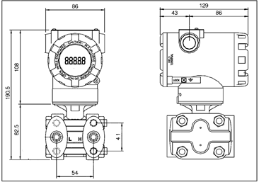
Figure 1.1 Dimensions of intelligent transmitter（unit：mm）
- Dimensions of NCS-PT105IISM Intelligent Transmitter

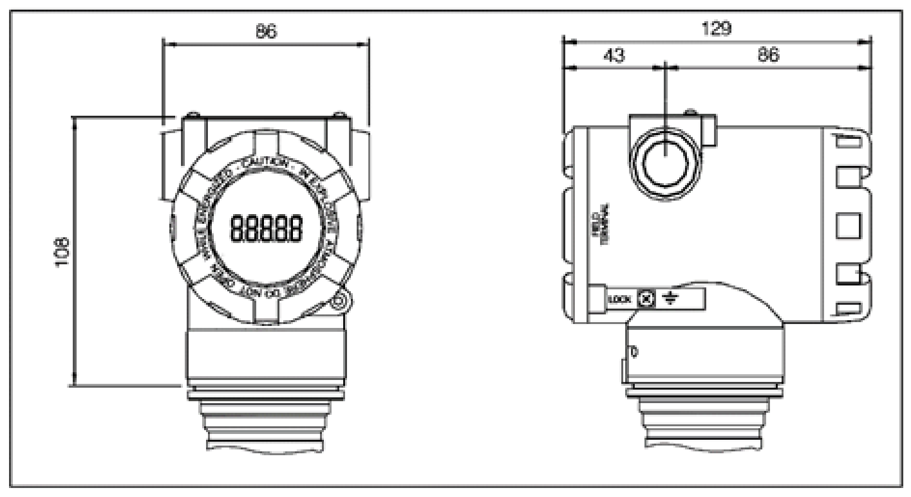
Figure 1.2 Dimensions of intelligent transmitter (unit：mm）

Installation
The guarantee of the measurement accuracy of the intelligent transmitter depends largely on the correct installation of the intelligent transmitter and the impulse pipe. In particular, the measurement of flow has a lot to do with the correct installation of the primary measuring element.

NCS-PT105IIM transmitter installation
For the installation of the intelligent transmitter, there are three types of mounting brackets available: pipe-mounted flat brackets, pipe-mounted curved brackets, and disk-mounted curved brackets. Correspondingly, there are three installation methods, namely flat bracket tube installation, curved bracket tube installation, and curved bracket plate installation.
Flat bracket tube installation is shown in Figure 2.1 .Use the 4 bolts provided to fix the transmitter on the panel mount bracket, and then use M10 bolts (user-supplied) to fix the panel mount bracket to the dial.
Curved bracket tube installation is shown in Figure 2.2. Use the 4 bolts provided to fix the transmitter on the pipe bend bracket, and then fix the pipe bend bracket to the horizontal pipe of about Φ50 mm through U-bolts.
Curved bracket plate installation is shown in Figure 2.3. Use the 4 bolts provided to fix the transmitter on the tube-mounted flat bracket, and then fix the tube-mounted flat bracket to the vertical tube of about Φ50 mm through U-bolts.
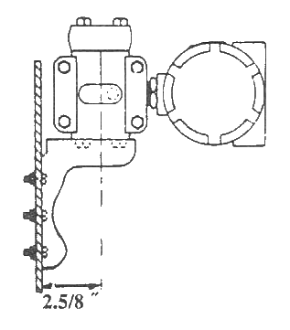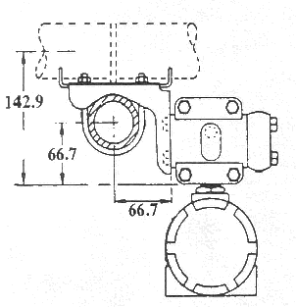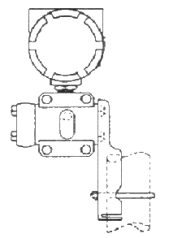
Figure2.1 B2 Flat bracket tube installation Figure2.2 B1 Curved bracket tube installation Figure2.3 B3 Curved bracket plate installation

Installation of impulse pipe
The correct installation of the intelligent transmitter relative to the process pipeline depends on the measured medium. Intelligent transmitters measure liquids, vapors or other gases. For different measured media, the relative positions of the pressure tap, intelligent transmitter and process pipeline are different.
When measuring the pressure of liquid medium, the pressure tap must be selected on the side of the process pipeline to avoid slag deposition. The intelligent transmitter should be installed below the side pressure port so that the gas can be discharged into the process pipeline, as shown in Figure 2.4.
When measuring steam pressure, the impulse pipe should be installed on the side of the process pipeline. The intelligent transmitter is installed below the pressure port. The impulse pipe should be filled with water to prevent the intelligent transmitter from coming into direct contact with steam. When measuring steam or other high temperature media, the working temperature of the intelligent transmitter should not exceed the limit, as shown in Figure 2.5.
When measuring the pressure of gas medium, the pressure port should be installed on the top or side of the process pipeline, and the intelligent transmitter should be installed above the side pressure port so that the liquid can be discharged into the process channel, as shown in Figure 2.6.
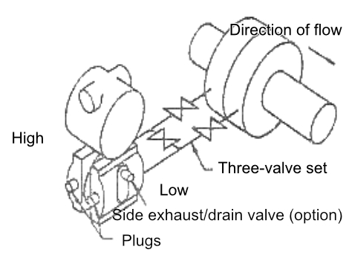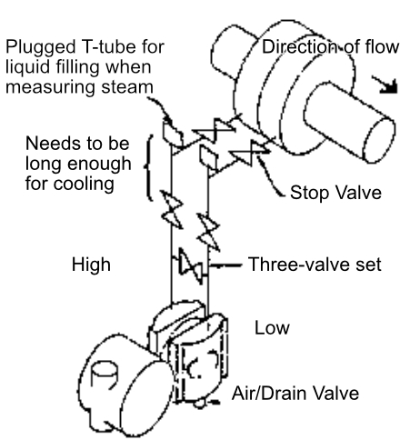
Figure 2.4 Schematic diagram of liquid medium connection. Figure 2.5 Schematic diagram of steam medium connection
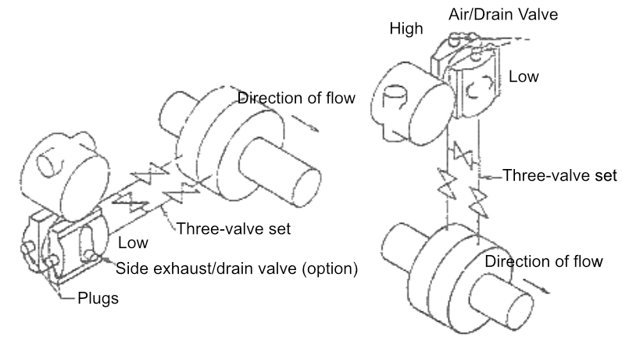
Figure 2.6 Gas medium connection diagram
Precautions for installation of impulse pipe and intelligent transmitter:
- The impulse pipe should be as short as possible if it meets the requirements.
- Corrosive or overheated media should not come into direct contact with the transmitter.
- The impulse pipe should be installed in a place with small temperature gradient and fluctuation.
- When measuring high temperature medium, refer to the operating temperature limit of the intelligent transmitter.
- The two impulse pipes should keep the same temperature, and the hydraulic height should be balanced (differential pressure type).
- In order to avoid the influence of friction, the pressure pipe should have a large enough diameter.
- When using isolating gas, the liquid level of the two impulse pipes should be the same (differential pressure type).
- When using a blowing system, the blowing system should be as close as possible to the pressure-taking port of the process pipeline, and the purified fluid should pass through the pipeline of the same size and length to the transmitter. Avoid the blowing fluid passing through the transmitter (differential pressure type).

NCS-PT105IISM transmitter installation
Intelligent transmitters can be mounted directly on 2-inch pipe or directly on a wall or dashboard.

Installation of impulse pipe
The correct installation of the intelligent transmitter relative to the process pipeline depends on the measured medium. Intelligent transmitters measure liquids, vapors or other gases. For different measured media, the relative positions of the pressure tap, intelligent transmitter and process pipeline are different.
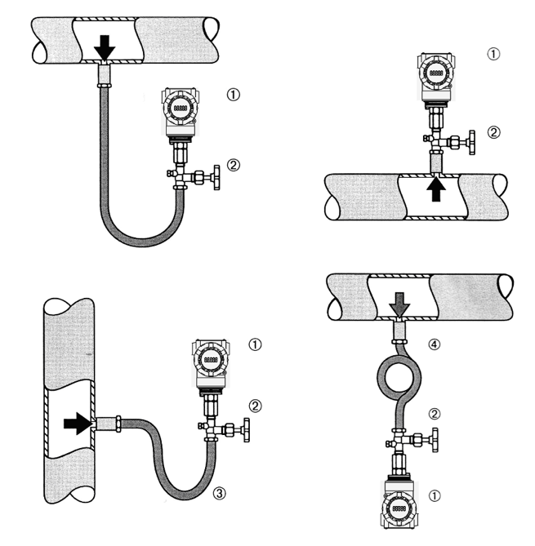
Figure 2.7 Schematic diagram of pressure pipe connection

1 | Transmitter | 2 | Impulse valve | 3 | Impulse pipe | 4 | Pipe

Wiring

Wiring of FF、PA、HART intelligent transmitter
The power and signal of the intelligent transmitter share a pair of cables, which are called bus cables. HART type intelligent transmitter can choose ordinary cable, FF type and PA type intelligent transmitter are recommended to use the field bus special cable recommended by IEC61158-2. The wiring terminals of the intelligent transmitter are located on the back cover side (marked with FIELD TERMINAL), and the wiring terminal board can be seen by unscrewing the back cover.
Figure 2.8 FF、PA intelligent transmitter wiring diagram Figure 2.9 HART intelligent transmitter wiring diagram
The left terminal of the terminal board is the signal positive terminal, the right terminal is the test positive terminal, and the middle terminal is the signal negative terminal and the test negative terminal. The power is supplied to the intelligent transmitter through the signal line, and the test terminal is only available in the HART type intelligent transmitter, which is used to connect the test instrument.
The signal wire is perforated to the terminal board through the lead wire, the positive signal is connected to the terminal on the left side of the terminal board (see Figure 2.9), and the negative signal is connected to the middle terminal of the terminal board. The shielding layer of the signal line can be floating or grounded at any point in the signal loop. When connecting the test instrument for testing the analog signal of the HART type intelligent transmitter, the threading method is the same as the signal line. The difference is that the positive input line of the test instrument is connected to the wiring terminal on the right side of the HART type intelligent transmitter terminal board (see Figure 2.10). The connection of the negative input line of the test instrument is the same as that of the signal negative.
Note: When connecting the HART type intelligent transmitter, do not connect the signal wire to the test terminal, otherwise the built-in diode will be burned. If the diode burns out, short circuit the two test terminals as an emergency.
The bus cable of the intelligent transmitter should not share the conduit or wire duct with the power lines of other devices, and should be kept away from high-power devices.

Wiring of DP intelligent transmitter
The wiring terminals of the intelligent transmitter are located on the back cover side (marked with FIELD TERMINAL), and the wiring terminal board can be seen by unscrewing the back cover.
Figure 2.7 DP intelligent transmitter wiring diagram
Provide a stable DC 24V power supply for the device.
Provides bus signals to devices.
The bus cable of the intelligent transmitter should not share the conduit or wire duct with the power lines of other devices, and should be kept away from high-power devices.
Figure 2.8 DIP switch configuration
When shipped from the factory, all DIP switches are "off".
The functions of setting the device address and restoring the factory defaults only take effect when the device is powered on again.

Re-calibration inspection
After the user gets the intelligent transmitter, it can be re-calibrated in the test room or on the installation site before it is put into use. Figure 2.13 lists the operational flow.
Figure 2.9 Intelligent transmitter recalibration inspection process
The content of the intelligent transmitter re-calibration check includes: function check and pressure check; for the specific check method, please refer to the following chapters.

Installation of explosion-proof transmitter
When used in hazardous locations, the on-site installation of explosion-proof transmitters must comply with the relevant regulations of GB3836.15-2000 "Electrical Equipment for Explosive Gas Environment Part 15: Electrical Installation in Hazardous Locations (except coal and mines)".
Explosion-proof transmitters must be equipped with safety barriers before they can be used in hazardous locations with explosive mixtures. The type and parameters of the safety barrier are selected according to the explosion-proof parameters in the table below. The suffix "X" of the explosion-proof certificate number means that the product must be matched with an isolated safety barrier to form an intrinsically safe explosion-proof system or that each grounding point in the intrinsically safe explosion-proof system where the product is located must ensure equipotential balance.
In order to maintain the explosion-proof performance of the installed intelligent transmitter, the following items must be paid attention to during installation:
- The housing of the intelligent transmitter must be well grounded.
- The circuit of the intelligent transmitter should not be disassembled or replaced by the user.
- The maximum distribution parameters of the signal cable are calculated according to the selected safety barrier parameters and the explosion-proof parameters of the intelligent transmitter.
- The signal cable of the intelligent transmitter must be separated from other cables, and can be shielded by steel pipes and wiring grooves.
- The shielding layer of the signal line of the intelligent transmitter can be grounded or grounded at a single point.
- The safety barrier should be installed on the rack at the exit of the safe place.

Working Principle and Structure
The pressure measurement principle of the intelligent transmitter is the same. They are all based on monocrystalline silicon pressure sensors, adopt advanced microcontroller and sensor digital measurement technology, and apply high-accuracy algorithms to ensure high-precision measurement of pressure signals. The communication interface of the intelligent transmitter adopts advanced HART, FF H1, PROFIBUS PA bus technology and PROFIBUS DP bus technology.
HART, FF H1, and PROFIBUS PA intelligent transmitters have the same logical structure and are composed of five parts, namely sensor, instrument card, communication card, liquid crystal display card, and port card. Refer to Figure 1.2 for the overall structure of the intelligent transmitter and Figure 3.1 for the schematic diagram of the product structure. Due to the same physical layer specifications, the FF and PA intelligent transmitters are identical in hardware; the communication cards and port cards of the FF and PA intelligent transmitters are the same as those of the HART intelligent transmitter. The card is different, but other parts are exactly the same as the corresponding parts of the HART type intelligent transmitter.
Figure 3.1 Product structure diagram
The DP pressure transmitter hardware board is composed of 5 parts, among which the liquid crystal card and the instrument card use the existing circuit board of the pressure transmitter, which will not be described in detail.
The communication card is composed of CPU, SRAM, VPC3+, EEPROM, etc. It is responsible for DP communication, data communication with the instrument card, driving liquid crystal display, and running various software algorithms.
The main functions of the isolation card include power conversion, respectively providing power to the communication card, instrument card, DP isolation driver, etc.; using an isolation chip to isolate the communication card from the instrument card and DP driver chip; transfer the DP address switch signal on the port card. For the communication card; there are also two dry tubes for the parameter setting of the magnetic rod.
Figure 3.2 Product structure diagram

On-site adjustment

Operating Instructions of Magnetic Bar
The intelligent transmitter can be adjusted on-site by inserting different combinations of magnetic rods into the two jacks marked "SPAN" and "ZERO" on the top of the electronic housing (below the nameplate), as shown in Figure 4.1
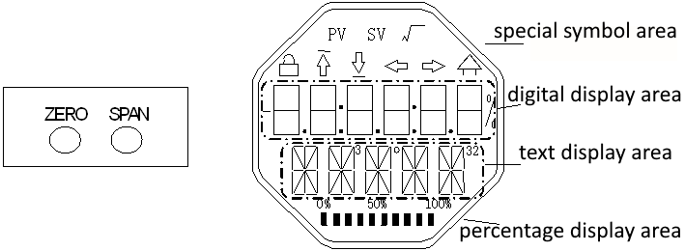
Figure 4.1 Magnet jack position and LCD full position display
The following sections will use different combinations of magnet insertion to simulate four virtual keys, which will facilitate the description of field tuning.
According to the function, the four virtual keys can be defined as the mode key ([M]), the input adjustment key ([↑], [↓]) and the confirmation key ([Enter]). The functions are as follows:
- Mode key [M]: Switch between various operable modes；
- Input adjustment key [↑]: Increment operation；
- Input adjustment key [↓]: decrement operation；
- Confirm key [Enter]: execute confirmation operation.
How to realize the operation of mode key, input adjustment key and confirmation key：
Mode key^{（1）} | Enter the adjustment key^{（1）} |  | Enter
[M] | [↓] | [↑] | [Enter]
Zero、Span Insert the magnets at the same time^{（2）} | Zero | Span | Zero、Span After inserting for 2 seconds at the same time, remove^{（2）}
Notice：
- The mode key [M] and the input adjustment keys ([↓], [↑]) are only one key operation to insert and pull out the magnetic bar, or you can insert the magnetic bar for a long time to operate in the same way. When performing a key operation, it is recommended to plug it in for 1 second before pulling it out, otherwise the operation may not be detected. Always press the button to automatically perform a key operation every 1 second.
- In order to avoid the conflict between the confirmation key and the mode key, when the confirmation operation is performed, when the progress bar reaches 100%, it indicates that the magnetic bar has been inserted for more than 2 seconds, and the confirmation operation is performed when the two magnetic bars are pulled out. If the magnetic bar is not pulled out after the progress bar reaches 100% for 3 seconds, perform the mode switching operation. The progress bar does not reach 100%, pull out the two magnetic rods, no operation.

General adjustment method
The following is the general adjustment method, please refer to the detailed description of each function for detailed operation.
In the measured value display mode, press the mode key [M] to switch the mode.
When the mode that needs to be adjusted is displayed, take out the two magnetic rods, and the current value of the value to be adjusted in this mode will be displayed on the LCD.
Press [↓] or [↑] to adjust, and after adjustment, press [Enter] to confirm.
Press the mode key [M] to switch back to the measured value display mode.
Notice：
1、Some functions do not need to be confirmed and are saved immediately after adjustment。
2、If there is no key operation for 1 minute (there is no magnetic rod inserted in both holes), it will automatically return to the normal display mode.

On-site calibration of HART intelligent transmitter
This section only describes the HART intelligent transmitter. The zero point, unit, range lower limit, range upper limit and other adjustment functions of the transmitter can be realized through on-site adjustment. For specific functions and key operations, see Table 4.1
Table4.1 Specific functions and key operations
Function | Model | Key Function |  |  | Function  show | show, explain
Function | [M] | [↑] | [↓] | [Enter] | Function  show | show, explain
Measurement value display |  |  |  |  |  | Display the measured value selected in mode 11
Error display |  |  |  |  |  | Mistake! When the transmitter fails, the text of the cause of the failure is displayed
Lower range limit | 03 | —— | —— | perform calibration | Fun03  LOWER | Set the lower limit of the main variable range with the current value
Upper range limit | 04 | —— | —— | perform calibration | Fun04  UPPER | Set the upper limit of the main variable range with the current value
Electronic damping | 05 | increment | Decrease |  | Fun05  DAMP | time constant in seconds  Setting range: 0.0 to 32.0
Passive lower range limit | 06 | preset  reduce | preset  increase | implement | Fun06  PVLRV | Manually set the lower limit of the primary variable range
Passive range upper limit | 07 | preset  reduce | preset  increase | implement | Fun07  PVURV | Manually set the upper limit of the main variable range
Main variable zero | 08 | —— | —— | perform calibration | Fun08  ZERO | Set the main variable zero point with the current value
Transfer Function | 10 | reduce | Increase | implement | Fun10  FUNCT | Set transfer function
Measured value display source | 11 | Choose from a variety of possibilities |  |  | Fun11  DISP | Display the desired measurement result
Unit of physical quantity | 12 | choose |  |  | Fun12  UNIT | Unit of physical quantity
After entering the field adjustment, long press the mode key [M] to switch between the above adjustment functions, as shown in Figure 4.2
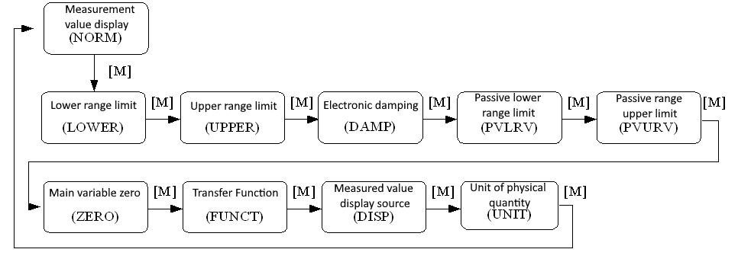
Figure4.2 Adjustment function switch diagram
In the mode switching state, the digital display area displays the function code, for example: "Fun03". The text display area displays the function description as shown in the figure above, for example: "LOWER".
Among them, modes 10, 11, and 12 do not need to be confirmed, and they are saved immediately after adjustment.

Measured value display
In the measured value display function, information on the configuration of the DSP display block is displayed.

Error display
Error messages may appear during local operation
Display | Explain
NumEr | Numerical exception
FNErr | Wrong mode number
Lock | Jumper set to configure protection

Operation steps for setting the lower limit of the range - Mode 03
Set the lower limit of the primary variable range with the current pressure value. Confirm that the lower limit value of the range applied to the intelligent transmitter is stable.
You can set the lower limit of the primary variable range as follows:
− Select mode 03, the LCD will display the current value and unit of the main variable, and the down arrow will be displayed in the special symbol area, indicating that the lower limit of the range is currently being set;
− Press the [Enter] key to set, if the setting is successful, it will display “OK”, if it is unsuccessful, it will display “Err”;
− Use [M] for mode switching

Operation steps for setting the upper limit of the range - Mode 04
Set the upper limit of the primary variable range with the current pressure value. Confirm that the upper range value applied to the intelligent transmitter is stable.
You can set the upper limit of the primary variable range as follows:
− Select mode 04, the LCD will display the current value and unit of the main variable, and the special symbol area will display the up arrow, indicating that the upper limit of the range is currently being set;
− Press [Enter] key to set, if the setting is successful, it will display “OK”, if it is unsuccessful, it will display “Err”;
− Use [M] for mode switching.

Steps to Set Electronic Damping - Mode 05
Sets the time constant for electronic damping in the range 0 to 32 seconds.
Set up this electronic damping as follows:
− Set mode 05;
− Use [↑] or [↓] to select damping;
− Use [M] for mode switching.
Damping only affects the output of the analog input function block.

Operation steps for passively setting the lower limit of the range - Mode 06
Passive range migration, set the lower limit of the main variable range.
You can set the lower limit of the primary variable range as follows:
− Adjust the lower limit value of the main variable range by using [↑] and [↓];
− Press the [Enter] key to set, if the setting is successful, it will display “OK”, if it is unsuccessful, it will display “Err”;
− Use [M] for mode switching.

Operation steps for passive setting of upper range limit - Mode 07
Passive range migration, set the upper limit of the main variable range.
You can set the upper limit of the primary variable range as follows:
− Adjust the lower limit value of the main variable range by using [↑] and [↓];
− Press [Enter] key to set, if the setting is successful, it will display “OK”, if it is unsuccessful, it will display “Err”;
− Use [M] for mode switching

Set the main variable zero operation steps - Mode 08
Set the primary variable zero point with the current pressure value. When the transmitter is installed and ready for operation, external influences such as the installation location, ambient temperature or allowable pressure associated with the installation (such as a water column in the pressure line leading to the transmitter) may cause the initial The zero point moves.
Zero calibration can be performed as follows:
− create a pressure scale;
− set mode 08;
− Press [Enter] key to set, “OK” will be displayed if successful, and “Err” will be displayed if unsuccessful;
− After the setting is successful, use [M] to switch the mode;
Switches back to the measured value display mode, the value 0 appears in the display area

Steps to Set Transfer Function - Mode 10
Set the current output method (transfer function).
You can set the transfer function as follows:
− Select mode 10, the LCD will display the current transfer function type;
− Select the transfer function type by using [↑] and [↓];
− Use [M] for mode switching

Steps for setting the measurement value display type - Mode 11
In this mode, you can select the value that will be displayed.
Select the source of the measured value as follows:
− Select mode 11, the value and description of the current display source will be displayed on the LCD;
− by using [↑] and [↓] to select the source of the measured value display;
− Use [M] for mode switching.
The supported measurement value display sources are given in the table below
Measurement value display type | LCD description
[0]main variable output | PV
[1]second variable output | SV
[2]Main variable current output | CU
[3]Primary variable percentage output | PN
[4]Main variable, current value loop output | LOOP
[5]Custom | USER

Steps to Set Primary Variable Units - Mode 12
In mode 12, you can change the unit of the host variable.
Set the primary variable units as follows:
− Select mode 12, the current unit identifier and description will be displayed on the LCD;
− Select a unit by using [↑] and [↓];
− Use [M] for mode switching

Field calibration of FF type intelligent transmitter
This section only describes the FF type intelligent transmitter. Through on-site adjustment, the adjustment function of the lower limit of the transmitter range, the upper limit of the range and the zero point of the main variable can be realized. For specific functions and key operations, see Table 4.2。
Table4.2 Specific functions and key operations
Function | Model | Key Function |  |  | Function  show | Show, explain
Function | [M] | [↑] | [↓] | [Enter] | Function  show | Show, explain
Measurement value display |  |  |  |  |  | Displays information about the DSP display block configuration
Error display |  |  |  |  |  | Mistake! When the transmitter fails, the text of the cause of the failure is displayed
Main variable zero | 15 | —— | —— | implement  calibration | Fun15  ZERO | Empty the pressure, differential pressure, flow, liquid level transmitters, and vacuum the absolute pressure transmitters, and the unit of measurement is the pressure unit
Lower range limit | 16 | Default increase | Preset reduction | implement | Fun16  LOWER | Adjust the lower limit of the characteristic curve
Upper range limit | 17 | Default increase | Preset reduction | implement | Fun17  UPPER | Adjust the upper limit of the characteristic curve
After entering the field adjustment, long press the mode key [M] to switch between the above adjustment functions, as shown in Figure 4.3
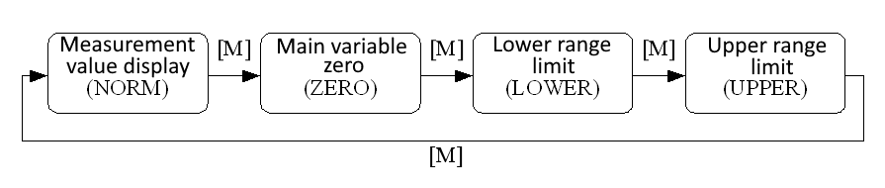
Figure 4.3 Adjustment function switch diagram

Measurement value display
In the measured value display function, information about the configuration of the DSP display block is displayed.

Error display
Error messages may appear during local operation.
Show | Explain
NumEr | Numerical exception
FNErr | Wrong mode number
Lock | Jumper set to configure protection

Operation steps for setting the main variable zero point - Mode 15
When the transmitter is installed and ready for operation, external influences such as the installation location, ambient temperature or allowable pressure associated with the installation (such as a water column in the pressure line leading to the transmitter) may cause the initial The zero point moves.
Zero calibration can be performed as follows:
− create a pressure scale;
− set mode 15;
− Press [Enter] key to set, “OK” will be displayed if successful, and “Err” will be displayed if unsuccessful;
− After successful calibration, return to measurement value display mode immediately.
The value 0 appears in the display area.

Operation steps for setting the lower limit of the range - Mode 16
The slope of the characteristic curve can be changed in this mode. The characteristic curve is rotated around the high set point. This function replaces zero adjustment (mode 08).
Perform the adjustment of the lower limit of the range as follows:
− Set mode 16. Displays the last adjusted process value and its associated units;
− If you only want to view this information, you can press the [M] key to switch the mode, otherwise you will apply the reference pressure;
− Use [↑] and [↓] to enter a reference pressure value starting from this value;
− Press [Enter] key to set, “OK” will be displayed if successful, and “Err” will be displayed if unsuccessful;
− Use [M] for mode switching.

Operation steps for setting the upper range limit - Mode 17
The slope of the characteristic curve can be changed in this mode. The characteristic curve rotates around the low set point.
Perform the adjustment of the upper range limit as follows:
− Set mode 17. Displays the last adjusted process value and its associated units;
− If you only want to view this information, you can press the [M] key to switch the mode, otherwise you will apply the reference pressure;
− Use [↑] and [↓] to enter a reference pressure value starting from this value;
− Press the [Enter] key to set, if the adjustment is successful, it will display “OK”, and if it is unsuccessful, it will display “Err”.
− Use [M] for mode switching

On-site calibration of PA type intelligent transmitter
This section only describes the PA type intelligent transmitter. Through on-site adjustment, the adjustment functions of the transmitter's bus address, display variable type, decimal point position, zero point, unit, range lower limit and range upper limit can be realized. For specific functions and key operations, see Table 4.3
Table 4.3 Specific functions and key operations
Function | Model | Key Function |  |  | Function  show | Show, explain
Function | [M] | [↑] | [↓] | [Enter] | Function  show | Show, explain
Measurement value display |  |  |  |  |  | Display the measured value selected in mode 11
error display |  |  |  |  |  | Mistake! When the transmitter fails, the text of the cause of the failure is displayed
Electronic damping | 05 | increment | Decrease |  | Fun05  DAMP | Time constant in seconds  Setting range: 0.0 to 32.0
Measured value display source | 11 | Choose from a variety of possibilities |  |  | Fun11  DISP | Display the desired measurement result
unit of physical quantity | 12 | choose |  |  | Fun12  UNIT | unit of physical quantity
Bus address | 13 | increase | reduce | implement | Fun13  ADDR | User address on PROFIBUS  (0…126)
Decimal point | 14 | Revise |  |  | Fun14  DECPT | Position of decimal point in display area
Main variable zero | 08 | —— | —— | implement  calibration | Fun08  ZERO | Empty the pressure, differential pressure, flow, liquid level transmitters, and vacuum the absolute pressure transmitters, and the unit of measurement is the pressure unit
Lower range limit | 16 | Default increase | Preset reduction | implement | Fun16  LOWER | Adjust the lower limit of the characteristic curve
Upper range limit | 17 | Default increase | Preset reduction | implement | Fun17  UPPER | Adjust the upper limit of the characteristic curve
Input range lower limit | 18 | Default increase | Preset reduction | implement | Fun18  IN 0% | Passive adjustment of the lower limit of the input range
Input range upper limit | 19 | Default increase | Preset reduction | implement | Fun19  IN 100% | Passive adjustment of the upper limit of the input range
Lower limit of output range | 20 | Default increase | Preset reduction | implement | Fun20  OUT 0% | Passive adjustment of the lower limit of the output range
Output range upper limit | 21 | Default increase | Preset reduction | implement | Fun20  OUT100% | Passive adjustment of the upper limit of the output range
Long press the mode key [M] to switch between the above adjustment functions, as shown in Figure 4.4
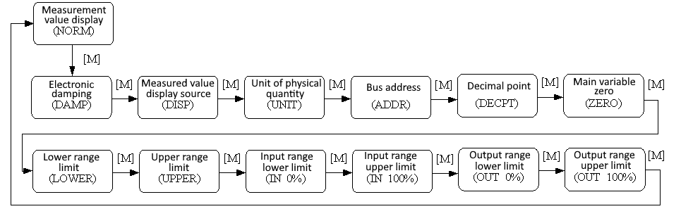
Figure 4.4 Adjustment function switch diagram

Measurement value display
In the measurement value display function, the measurement value selected in mode 11 is displayed. The unit of physical quantity is set in mode 12, and the position of the decimal point is set in mode 14.

Error display
Error messages may appear during local operation.
Show | Explain
NumEr | Numerical exception
FNErr | Wrong mode number
UNErr | Unit does not match
Lock | Jumper set to configure protection

Steps to Set Electronic Damping - Mode 05
Sets the time constant for electronic damping in the range 0 to 32 seconds.
Set up this electronic damping as follows:
− set mode 05;
− Use [↑] or [↓] to select damping;
− Use [M] for mode switching.
Damping only affects the output of the analog input function block.

Steps to set the measurement value display source - Mode 11
In this mode, you can choose the value that will be displayed.
In SIMATIC PDM, this is the "Transmitter Type" parameter.
You can choose the source of the measurement value in the following ways:
− set mode 11;
− by using [↑] and [↓] to select the source of the measured value display;
− Use [M] for mode switching.
In Mode 12, the assignable unit of physical quantity depends on the source from which the measurement value is displayed.
The supported measurement value display sources are given in the table below.
Measured value display source | LCD display auxiliary information
[0]Main variable output of pressure conversion block | PRIM
[1]Pressure Transformer Block Secondary Variable Output | SEC1
[2]AI function block output | AIOUT
[3]Pressure transducer block sensor raw value | SENS
[4]Pressure transducer block sensor temperature value | TEMP

Operation steps for setting physical quantity units - Mode 12
Set the physical quantity unit by selecting an option from the list. The group of units that can be selected depends on the source of the measurement display (mode 11).
You can set physical quantity units in the following ways:
− Set mode 12. The identifier of the current unit appears in the measurement value display, and the corresponding plain text appears in the unit display.
− Select a unit by using [↑] and [↓];
− Use [M] for mode switching.
The pressure unit is shown in Table 4.4：
Table 4.4 pressure unit
Unit Code | Unit | Unit Code | Unit | Unit Code | Unit
1130 | Pa | 1140 | atm | 1150 | mmH₂O(4 ℃)
1131 | GPa | 1141 | psi | 1151 | mmH₂O(68 ℃)
1132 | MPa | 1142 | psia | 1152 | ftH₂O
1133 | kPa | 1143 | psig | 1153 | ftH₂O(4 ℃)
1134 | mPa | 1144 | g/cm² | 1154 | ftH₂O(68 ℃)
1135 | μPa | 1145 | kg/cm² | 1155 | inHg
1136 | hPa | 1146 | inH₂O | 1156 | inHg(0 ℃)
1137 | bar | 1147 | inH₂O(4 ℃) | 1157 | mmHg
1138 | mbar | 1148 | inH₂O(68 ℃) | 1158 | mmHg(0 ℃)
1139 | torr | 1149 | mmH₂O

Steps to Set Bus Address - Mode 13
In mode 13, you can set the user address of the device in PROFIBUS. The allowed range is 0 to 126.
Set the PROFIBUS address as follows:
− Set mode 13. The current user address will appear in the measured value display;
− Use [↑] and [↓] to modify this address within the allowed range;
− Press the [Enter] key to set, “OK” will be displayed if successful, and “Err” will be displayed if unsuccessful.
− Use [M] for mode switching

Steps for setting the decimal point - Mode 14
Measurements can be displayed with up to 5 decimal places of precision.
Move the decimal point position as follows:
− Set mode 14. The format of the current position of the decimal point appears in the measurement value display area;
− Use [↑] and [↓] to select the desired display format;
8.88888 88.8888 888.888 8888.88 88888.8 888888
− Use [M] for mode switching

Operation steps for setting the main variable zero point - Mode 15
When the transmitter is installed and ready for operation, external influences such as the installation location, ambient temperature or allowable pressure associated with the installation (such as a water column in the pressure line leading to the transmitter) may cause the initial The zero point moves.
Zero calibration can be performed as follows:
− create a pressure scale;
− set mode 15;
− Press the [Enter] key to set, “OK” will be displayed if successful, and “Err” will be displayed if unsuccessful.
− After successful calibration, return to measurement value display mode immediately.
The value 0 appears in the display area

Operation steps for setting the lower limit of the range - Mode 16
The slope of the characteristic curve can be changed in this mode. The characteristic curve is rotated around the high set point. This function replaces zero adjustment (mode 08).
Perform the adjustment of the lower limit of the range as follows:
− Set mode 16. Displays the last adjusted process value and its associated units;
− If you only want to view this information, you can press the [M] key to switch the mode, otherwise you will apply the reference pressure;
− Use [↑] and [↓] to enter a reference pressure value starting from this value;
− Press the [Enter] key to set, “OK” will be displayed if successful, and “Err” will be displayed if unsuccessful.
− Use [M] for mode switching

Operation steps for setting the upper range limit - Mode 17
The slope of the characteristic curve can be changed in this mode. The characteristic curve rotates around the low set point.
Perform the adjustment of the upper range limit as follows:
− Set mode 17. Displays the last adjusted process value and its associated units;
− If you only want to view this information, you can press the [M] key to switch the mode, otherwise you will apply the reference pressure;
− Use [↑] and [↓] to enter a reference pressure value starting from this value;
− Press the [Enter] key to set, “OK” will be displayed if successful, and “Err” will be displayed if unsuccessful.
− Use [M] for mode switching

Operation steps for setting the lower limit of the input range - Mode 18
In this mode, the lower limit of the input range can be passively adjusted.
Perform the adjustment of the upper range limit as follows:
− Set mode 18. Displays the last adjusted process value and its associated units;
− Use [↑] and [↓] to enter a reference value starting from this value;
− Press the [Enter] key to set, “OK” will be displayed if successful, and “Err” will be displayed if unsuccessful.
− Use [M] for mode switching

Operation steps for setting the upper limit of the input range - Mode 19
In this mode, the upper limit of the input range can be passively adjusted.
Perform the adjustment of the upper range limit as follows:
− Set mode 19. Displays the last adjusted process value and its associated units;
− Use [↑] and [↓] to enter a reference value starting from this value;
− Press the [Enter] key to set, “OK” will be displayed if successful, and “Err” will be displayed if unsuccessful.
− Use [M] for mode switching

Operation steps for setting the lower limit of the output range - Mode 20
In this mode, the lower limit of the output range can be passively adjusted.
Perform the adjustment of the upper range limit as follows:
− Set mode 20. Displays the last adjusted process value and its associated units;
− Use [↑] and [↓] to enter a reference value starting from this value;
− Press the [Enter] key to set, “OK” will be displayed if successful, and “Err” will be displayed if unsuccessful.
− Use [M] for mode switching

Operation steps for setting the upper limit of the output range – Mode 21
In this mode, the upper limit of the output range can be passively adjusted.
Perform the adjustment of the upper range limit as follows:
− Set mode 21. Displays the last adjusted process value and its associated units;
− Use [↑] and [↓] to enter a reference value starting from this value;
− Press the [Enter] key to set, “OK” will be displayed if successful, and “Err” will be displayed if unsuccessful.
− Use [M] for mode switching

On-site calibration of DP type intelligent transmitter
Through on-site adjustment, the adjustment functions of the transmitter's bus address, display variable type, decimal point position, zero point, unit, range lower limit and range upper limit can be realized. For specific functions and key operations, see Table 4.5
Table 4.5 Specific functions and key operations
Function | model | Key Function |  |  | Function  show | show, explain
Function | [M] | [↑] | [↓] | [Enter] | Function  show | show, explain
Measurement value display |  |  |  |  |  | Display the measured value selected in mode 11
Error display |  |  |  |  |  | Mistake! When the transmitter fails, the text of the cause of the failure is displayed
Electronic damping | 05 | increment | Decrease |  | Fun05  DAMP | time constant in seconds  Setting range: 0.0 to 32.0
Measurements  show source | 11 | Choose from a variety of possibilities |  |  | Fun11  DISP | Display the desired measurement result
Unit of physical quantity | 12 | choose |  |  | Fun12  UNIT | unit of physical quantity
Decimal point | 14 | Revise |  |  | Fun14  DECPT | Position of decimal point in display area
Main variable zero | 08 | —— | —— | implement  calibration | Fun08  ZERO | For the pressure, the differential pressure transmitter is vented, and the absolute pressure transmitter is evacuated, and the unit of measurement is the pressure unit
Lower range limit | 16 | Default increase | Preset reduction | implement | Fun16  LOWER | Adjust the lower limit of the characteristic curve
Upper range limit | 17 | Default increase | Preset reduction | implement | Fun17  UPPER | Adjust the upper limit of the characteristic curve
Input range lower limit | 18 | Default increase | Preset reduction | implement | Fun18  IN 0% | Passive adjustment of the lower limit of the input range
Input range upper limit | 19 | Default increase | Preset reduction | implement | Fun19  IN 100% | Passive adjustment of the upper limit of the input range
Lower limit of output range | 20 | Default increase | Preset reduction | implement | Fun20  OUT 0% | Passive adjustment of the lower limit of the output range
Output range upper limit | 21 | Default increase | Preset reduction | implement | Fun20  OUT 100% | Passive adjustment of the upper limit of the output range
After entering the field adjustment, long press the mode key [M] to switch between the above adjustment functions, as shown in Figure 4.5
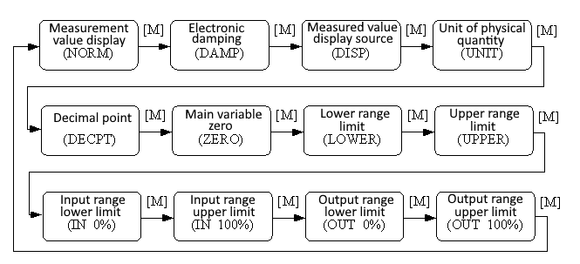
Figure 4.5 Adjustment function switch diagram

Measurement value display
In the measurement value display function, the measurement value selected in mode 11 is displayed. The unit of physical quantity is set in mode 12, and the position of the decimal point is set in mode 14

Error display
An error message occurs during local operation and is displayed for approximately 10 seconds after the error occurs.

Steps to Set Electronic Damping - Mode 05
Sets the time constant for electronic damping in the range 0 to 32 seconds.
Set up this electronic damping as follows：
− set mode 05;
− Use [↑] or [↓] to select damping;
− Use [M] for mode switching.
Damping only affects the output of the analog input function block.

Steps to set the measurement value display source - Mode 11
In this mode, you can select the value that will be displayed.
In SIMATIC PDM, this is the "Transmitter Type" parameter.
You can choose the source of the measurement value in the following ways:
− set mode 11;
− by using [↑] and [↓] to select the source of the measured value display;
− Use [M] for mode switching.
In Mode 12, the assignable unit of physical quantity depends on the source from which the measurement value is displayed.
The supported measurement value display sources are given in the table below.
Measured value display source | LCD display auxiliary information
[0]Main variable output of pressure conversion block | PRIM
[1]Pressure Transformer Block Secondary Variable Output | SEC1
[2]AI function block output | AIOUT
[3]Pressure transducer block sensor raw value | SENS
[4]Pressure transducer block sensor temperature value | TEMP

Operation steps for setting physical quantity units - Mode 12
Set the physical quantity unit by selecting an option from the list. The group of units that can be selected depends on the source of the measurement display (mode 11).
You can set physical quantity units in the following ways:
− Set mode 12. The identifier of the current unit appears in the measurement value display, and the corresponding plain text appears in the unit display.
− Select a unit by using [↑] and [↓];
− Use [M] for mode switching.
The pressure unit is shown in Table 4.6：
Table 4.6 Pressure unit
Unit Code | Unit | Unit Code | Unit | Unit Code | Unit
1130 | Pa | 1140 | atm | 1150 | mmH2O(4℃)
1131 | GPa | 1141 | psi | 1151 | mmH2O(68℃)
1132 | MPa | 1142 | psia | 1152 | ftH2O
1133 | KPa | 1143 | psig | 1153 | ftH2O(4℃)
1134 | mPa | 1144 | g/cm2 | 1154 | ftH2O(68℃)
1135 | μPa | 1145 | kg/cm2 | 1155 | inHg
1136 | hPa | 1146 | inH2O | 1156 | inHg(0℃)
1137 | bar | 1147 | inH2O(4℃) | 1157 | mmHg
1138 | mbar | 1148 | inH2O(68℃) | 1158 | mmHg(0℃)
1139 | torr | 1149 | mmH2O

Steps for setting the decimal point - Mode 14
Measurements can be displayed with up to 5 decimal places of precision.
Move the decimal point position as follows:
− Set mode 14. The format of the current position of the decimal point appears in the measurement value display area;
− Use [↑] and [↓] to select the desired display format;
8.88888 88.8888 888.888 8888.88 88888.8 888888
− Use [M] for mode switching

Operation steps for setting the main variable zero point - Mode 15
When the transmitter is installed and ready for operation, external influences such as the installation location, ambient temperature or allowable pressure associated with the installation (such as a water column in the pressure line leading to the transmitter) may cause the initial The zero point moves.
Zero calibration can be performed as follows:
− create a pressure scale;
− set mode 15;
− Press [Enter] to set, if the adjustment is successful, it will display “OK”, if it is unsuccessful, it will display “Err”;
− After successful calibration, return to measurement value display mode immediately.
The value 0 appears in the display area.

Operation steps for setting the lower limit of the range - Mode 16
The slope of the characteristic curve can be changed in this mode. The characteristic curve is rotated around the high set point. This function replaces zero adjustment (mode 08).
Perform the adjustment of the lower limit of the range as follows:
− Set mode 16. Displays the last adjusted process value and its associated units;
− If you only view this information, you can press the [M] key to switch the mode, otherwise you will apply the reference pressure;
− Use [↑] and [↓] to enter a reference pressure value starting from this value;
− Press [Enter] to set, if the adjustment is successful, it will display “OK”, if it is unsuccessful, it will display “Err”;
− Use [M] for mode switching

Operation steps for setting the upper range limit - Mode 17
The slope of the characteristic curve can be changed in this mode. The characteristic curve rotates around the low set point.
Perform the adjustment of the upper range limit as follows:
− Set mode 17. Displays the last adjusted process value and its associated units;
− If you only view this information, you can press the [M] key to switch the mode, otherwise you will apply the reference pressure;
− Use [↑] and [↓] to enter a reference pressure value starting from this value;
− Press [Enter] to set, if the adjustment is successful, it will display “OK”, if it is unsuccessful, it will display “Err”;
− Use [M] for mode switching.

Operation steps for setting the lower limit of the input range - Mode 18
In this mode, the lower limit of the input range can be passively adjusted.
Perform the adjustment of the upper range limit as follows:
− Set mode 18. Displays the last adjusted process value and its associated units;
− Use [↑] and [↓] to enter a reference value starting from this value;
− Press [Enter] to set, if the adjustment is successful, it will display “OK”, if it is unsuccessful, it will display “Err”;
− Use [M] for mode switching

Operation steps for setting the upper limit of the input range - Mode 19
In this mode, the upper limit of the input range can be passively adjusted.
Perform the adjustment of the upper range limit as follows:
− Set mode 19. Displays the last adjusted process value and its associated units;
− Use [↑] and [↓] to enter a reference value starting from this value;
− Press [Enter] to set, if the adjustment is successful, it will display “OK”, if it is unsuccessful, it will display “Err”;
− Use [M] for mode switching

Operation steps for setting the lower limit of the output range - Mode 20
In this mode, the lower limit of the output range can be passively adjusted.
Perform the adjustment of the upper range limit as follows:
− Set mode 20. Displays the last adjusted process value and its associated units;
− Use [↑] and [↓] to enter a reference value starting from this value;
− Press [Enter] to set, if the adjustment is successful, it will display “OK”, if it is unsuccessful, it will display “Err”;
− Use [M] for mode switching.

Operation steps for setting the upper limit of the output range – Mode 21
In this mode, the upper limit of the output range can be passively adjusted.
Perform the adjustment of the upper range limit as follows:
− Set mode 21. Displays the last adjusted process value and its associated units;
− Use [↑] and [↓] to enter a reference value starting from this value;
− Press [Enter] to set, if the adjustment is successful, it will display “OK”, if it is unsuccessful, it will display “Err”;
− Use [M] for mode switching.

Restore meter data to factory defaults
Restoring the instrument data to the factory setting is a special operation, and there is no function code. After doing this, all configuration data will disappear and the factory state will be restored. Please use with caution.
You can restore the meter data to the factory value in the following ways:
− switch off the power supply of the instrument;
− Insert the two magnetic rods into the "Zero" hole and the "Span" hole at the same time;
− Power on the meter again, the LCD will display “RST?” at this moment;
− If you want to restore the data of the meter to the factory value, take out the two magnetic rods, and insert the two magnetic rods at the same time again. When the progress bar reaches 100%, take out the two magnetic rods again, and the LCD will display "R_OK", indicating that the recovery is successful;
− If you do not want to restore the meter data to the factory value, take out the two magnetic rods, wait for 5 seconds, and then it can be used normally.
Notice:
FF type, PA type intelligent transmitter, operate according to the above method. If there is an RST jumper, it will directly restore the factory value, and "RST?" will not appear.
If the DIP switch is restored to the factory default position "on", the factory value will be directly restored, and "RST?" will not appear.
When the progress bar does not reach 100%, take out the two magnetic rods, or cancel the operation of restoring the instrument data to the factory value.

On site calibration of Wireless HART smart transmitter
This section only describes the WirelessHART smart transmitter. The operation can be verified on-site in the following three locations: using the WirelessHART configuration tool on a PC; Use the 475 communicator; Integrated web page for intelligent WirelessHART gateway.
If the WirelessHART smart transmitter is configured with a network ID and join key, and the network polling time is long enough, the transmitter should be connected to the network. To verify connectivity, please open the integrated web page of the Microcyber G1100 smart WirelessHART gateway and navigate to the 'Node Details' page.
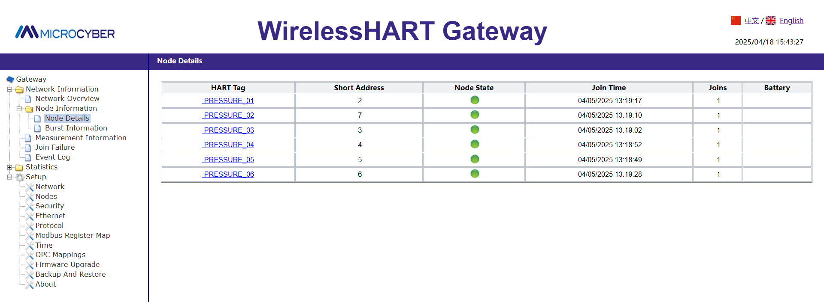
Figure 4.6 Node details page of WirelessHART gateway
This page will display parameters such as the HART tag, node status, joining time, and joining times of the transmitter. To learn more details about a specific device, please click on the tag name.

WirelessHART configuration tool
The WirelessHART configuration tool is a debugging software developed by Microcyber specifically for instrument configuration. The configuration tool can configure wireless network information, device update cycles, and monitor the process of wireless transmitters joining the network.
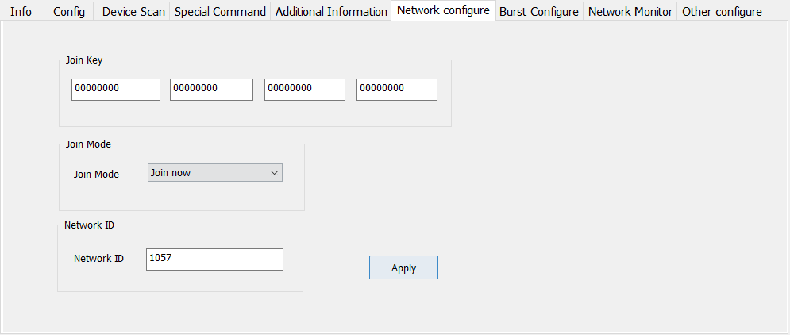
Figure 4.7 Configuration Tool - Network Configuration Tab

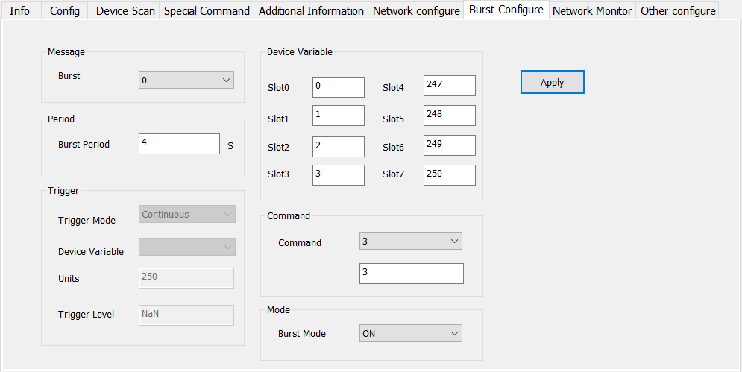
Figure 4.8 Configuration Tool - Burst Configuration Tab

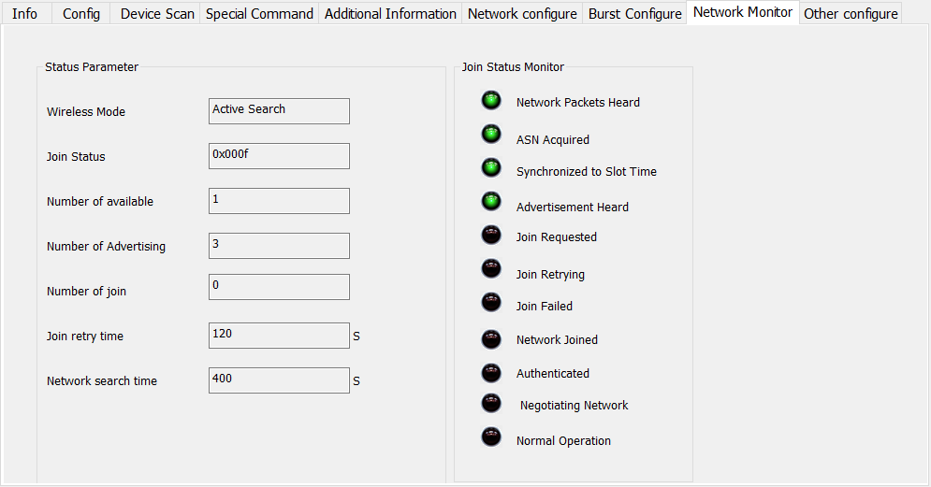
Figure 4.9 Configuration Tool – Network Monitor Tab

475 communicator
To verify the operation of the device using a HART communication device, the DD file of the Wireless HART smart transmitter is required. For example, when using the 475 communicator to connect to a device, you can view the network status of the transmitter in the Wireless Status menu.
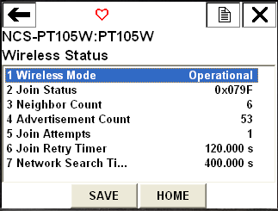
Figure 4.10 475 communicator WirelessHART

WirelessHART gateway
Use Microcyber's G1100 intelligent WirelessHART gateway to integrate a web page to verify device operation, navigate to the "Measurement Information" page.
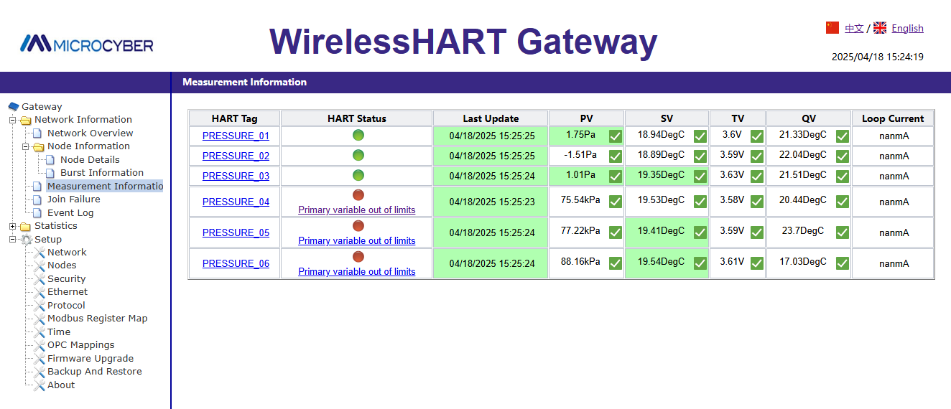
Figure 4.11 Measurement Information page of G1100 WirelessHART gateway

This page will display the HART tag, PV, SV, TV, QV, and loop current data of the transmitter. The green status indicator light indicates that the device is working properly, while the red indicator light indicates that there is a problem with the device or its communication. To learn more details about a specific device, please click on the tag name.

Troubleshooting
The most common reason for incorrect operation is incorrect network ID and join key configuration. The network ID and join key in the device must be consistent with the smart wireless gateway. The network ID and joining key can be obtained on the "Settings" ->"Network Settings" page of the wireless gateway web page.

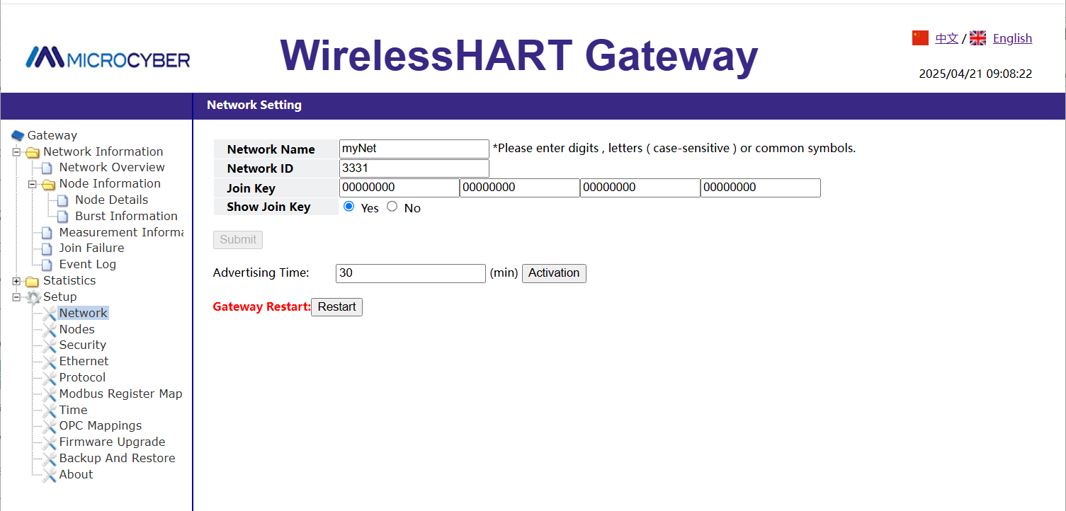
Figure 4.14.2 Network Settings page of G1100 WirelessHART gateway

HART Type Intelligent Transmitter Configuration

Topologic Connection
The connection of the HART intelligent transmitter includes Point-to-Point connection and Multi-Point connection.
- Point-to-Point Connection (Figure 5.1）
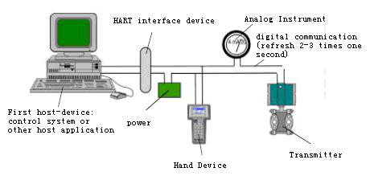
Figure 5.1 Point-to-Point Connection

Feature:
- It can be connected to the upper level control system through the ordinary AI input module and HART communication device;
2) Mixed use of the analog and digital communication;
3) The device address is 0.
- Multi-Point Connection (Figure 5.2）
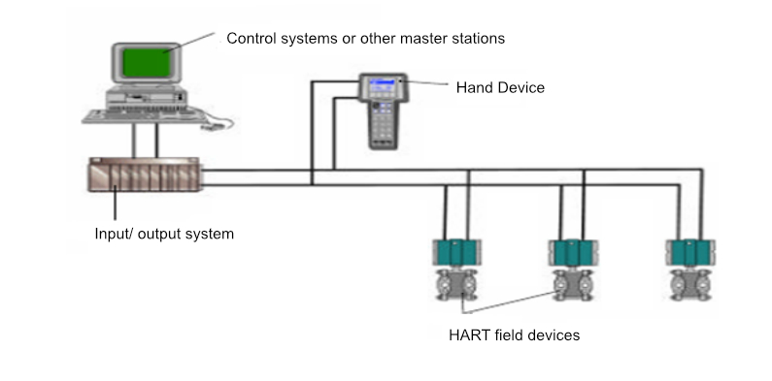
Figure 5.2 Multi-Point Connection

Feature：
- Can be connected to the upper level control system through HART communication device;
- Only use HART system digital function , and the fixed current on wire is 4mA;
- Up to 63 device networking is supported in the short address format.

Function Configuration
The intelligent transmitter can be debugged using the HART configuration software, including the following five functions:
- Basic information configuration: configure the basic information of online equipment, including label, address, date, assembly number information, etc.;
- Configuration information: configuration information of online equipment, including main variable range, damping and other information;
- Current calibration: can calibrate (4~20) mA current and currently using two-point calibration, namely 4 mA and 20 mA. While the user can set the fixed current output mode to test the current accuracy;
- Special command: can configure the LCD display type, configuration of small signal resection, user unit, special curve configuration and other functions.
- Additional information: Ability to configure sensor information for the entire pressure meter and user custom saturation / alarm current values.

Configuration Environment
- PC machine；
- HART Modem；
- Match resistance (250～550) Ω；
- Standard pressure source.

Basic Information Configuration
Through the dialog of basic information, the basic information of the intelligent transmitter can be read or modified, including device address, message, description, label, date, assembly number, alarm, write protection, manufacturer ID, manufacturer, equipment type, equipment ID, long address, and version information, as shown in Figure 5.3.
After the information is modified, it can be downloaded to the device by pressing the "Application" button. If not sent successfully, the device information will be restored to the previously modified content. If you abandon the modification, you can choose the “Exit ” button to exit the basic information operation.
- The maximum length of the label is 8 specified characters;
- Description can enter up to 16 specified characters;
- Messages can enter up to 32 characters;
- The address selection range is 0~63;
- The maximum assembly number length is 6 specified characters.
- The whole machine series number can not be modified;
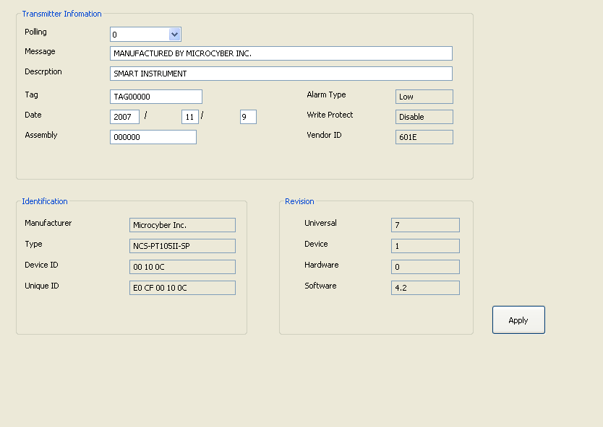
Figure 5.3 Basic Info Tab

Configuration of Configuration Information
Through the configuration information dialog box, you can read or modify the configuration information of the intelligent transmitter, including the value and unit of the main variable and the second variable of the device (here refers to pressure and temperature), the current value, the percentage, the output information of the main variable (damping value, unit, upper limit of range, lower limit of range, output transfer function), sensor information (serial number, upper limit, lower limit, minimum range, unit), etc., as shown in Figure 5.4.
- Primary variable unit configuration: the change of the main variable unit directly affects the variables associated with the unit, such as the upper and lower limit of the range, the upper and lower limit of the sensor, and the minimum range.When modifying units, the upper and lower limits of the main variable range cannot be modified at the same time.
- Damping value configuration: the damping parameter range ranges from 0 to 32 seconds.
- Set range lower limit: take the main variable value of the currently measured as the lower range range (the upper limit is adjusted); if the range upper limit exceeds the sensor upper limit, the sensor upper range upper limit is set after adjustment, and the range changes accordingly.
- Set the upper limit: with the current measured main variable value as the upper limit and change the upper limit of the sensor, set the upper limit as the adjusted upper limit.
- Primary variable zero: correct the offset of primary variable zero due to the influence of installation position.
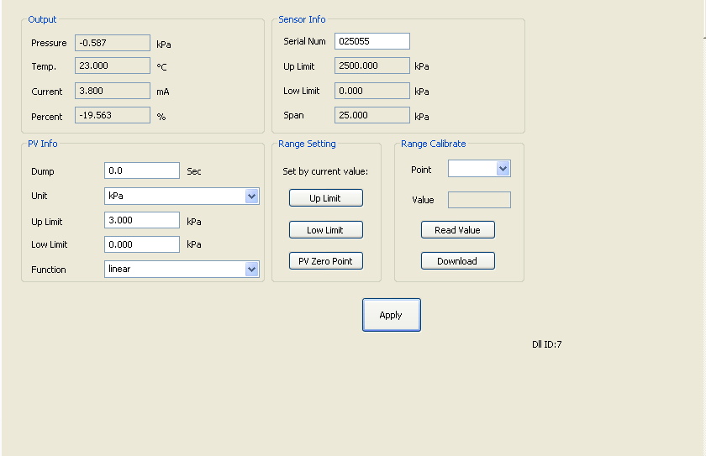
Figure 5.4 The Configuration Information Tab
- Range calibration: after the range migration, calibration the upper and lower range limits.The calibration process is as follows:
    - The transmitter adds the standard range lower limit pressure, select the calibration point "range lower limit", as shown in Figure 5.5, click "Get the current value", display the calibration data in the "correct value", click "download", then the actual pressure value is the lower range lower pressure value, and the current output is 4 mA.
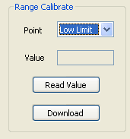
Figure 5.5 Range Calibration-calibration Range Lower Limit
    - The transmitter adds the standard upper limit pressure. After the pressure is stable, select the calibration point "upper limit", as shown in Figure 5.6, click "Get the current value", display the calibration data in the "correction value", click "Download", then the actual pressure output is the upper range pressure value, and the current output is 20 mA;
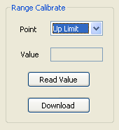
Figure 5.6 Scale Calibration-calibration range upper limit

Current Calibration and Fixed Current Output
The user can calibrate the intelligent transmitter analog output current of 4 mA, 20 mA and output fixed current.When calibrating the current and fixed current output, the polling address of the intelligent transmitter can only be 0, and other polling addresses will prompt the error message "in multipoint mode".In addition, it is necessary to string in more than five and a half precision ammeters in the intelligent transmitter output loop.
4 mA and 20 mA current calibration: In Figure 5.7, select the current value to be calibrated. After the output current value is stable, input the reading of the ammeter into the "Adjustment value" box and click "Apply" to observe whether the output current meets the requirements. If it does not meet, continue the adjustment ac
Fixed current output: In Figure 5.7, enter the current value that the intelligent transmitter will fixed output in "Fixed Current Value" and click "Enter / Exit Fixed Current Mode" to enter the fixed current output mode.The button displays "Exit Fixed Current Mode". In order to exit the fixed current mode, click the button again.
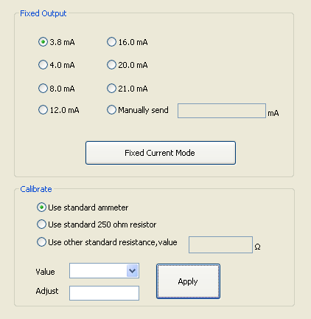
Figure 5.7 Calibrate Current Tab

Saturable Fixed Output (Manufacturer setting, not configurable)
When the HART intelligent transmitter runs continuously, it constantly compares the value of the main variable with the upper and lower limits. When the value of the main variable exceeds the upper and lower range, the intelligent transmitter output saturation current, indicating that the main variable exceeds the range.When the main variable is above the upper limit, the intelligent transmitter output high alarm current; when below the lower limit, the intelligent transmitter output low alarm current.

Special Command
The special command tab on the configuration software is shown in Figure 5.8:
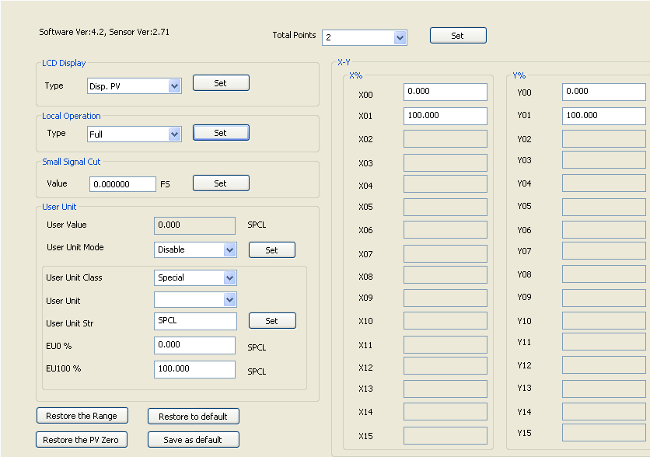
Figure 5.8 The Special Commands Tab
In this tab includes:
- LCD display type: used to set the main variable to display the transmitter LCD head.You can be set to: display the main variable value, the second variable value, the current value, the display percentage, the main variable and the current value alternately display and the user value.
- Local operation: Configure the functional permission of the local magnetic rod operation through the software.With three settings: set to Cancel, the local magnet rod operation will be invalid; set to simplified version, the geomagnetic function is limited to adjust zero and full range points; set to Full Version, the local magnet rod can perform all local tuning functions.
- Small signal excision: the percentage of removing small signals ranges from 0.0 to 0.005.
- User unit: In applications or where relative adjustment is selected, the new unit can be defined by the custom unit (user unit) function.These measurements include applications of fluid level, volume, flow rate, or mass flow rate obtained indirectly through pressure measurements.Users must change the User Unit Mode to Enable before using this feature.
For the reference, one value corresponds to 0% of the measurement and the other value corresponds to 100%.
- 0% -Required reading when pressure equals a low-end value (PV% = 0%, or output equals 4mA in transmitter mode).
- 100% - Required reading when the pressure is equal to the high-end value (PV% =100%, or the output equals 20mA in transmitter mode).
User custom units can be selected from a drop-down list contained in the User Units. Make new measurements to be associated with new units so that all monitoring systems equipped with the HART protocol can access the special units included in the table. The user is responsible for the consistency of this information. This pressure transmitter cannot verify that the corresponding 0% and 100% values set by the user match the selected units.
If the user needs a special unit that is not included in the "User Unit," the transmitter allows the user to enter five characters in the "User unit string" to create a new unit.
Example: The transmitter PT105II is connected to a vertical cylinder tank (6 m long, 2 m diameter) and is linearized using the capacity meter data in the linearized table.Measured by high end pressure pressure, the transmitter is 250mm under the base. The measured liquid is the water at 20℃.
Tank volume：[(π*d2)/4]*l=[(π*22)/4]π*6 = 18,85 m3.
The pressure should be reduced from the measured pressure to obtain the tank level. Therefore, perform the following reference-free source calibration as follows:
After calibration is completed:
Range lower limit = 250mmH2O
Range upper limit = 2250 mmH2O
Pressure unit = mmH2O
In the custom units:
EU0% = 0
EU100% = 18.85
User Unit = m3
After you can customize the units, the PT105II begins to indicate the new measurements.
- Linear table X-Y：
If the output transfer function of the pressure gauge is properly set to the Special Curve, the output follows the curve given by the table (X-Y).
If 4 to 20 m A is expected to be proportional to the volume or mass of the liquid in the tank, you must convert the pressure measurement "X" into the volume (or mass) "Y" with the table shown in the table below.
Spot | Pressure | X | Volume | Y
1 | - | -10% | - | -0.6%
2 | 250mmH₂O | 0% | 0m³ | 0%
3 | 450 mmH₂O | 10% | 0.98 m³ | 5.22%
4 | 750 mmH₂O | 25% | 2.90 m³ | 15.38%
5 | 957.2 mmH₂O | 35.36% | 4.71 m³ | 25%
6 | 1050 mmH₂O | 40% | 7.04 m³ | 37.36%
7 | 1150 mmH₂O | 45% | 8.23 m³ | 43.65%
8 | 1250 mmH₂O | 50% | 9.42 m³ | 50%
… | … | … | … | …
15 | 2250mmH₂O | 100% | 18.85 m³ | 100%
16 | - | 110% | - | 106%
As the example above, these points are freely distributed over any desired X value.To achieve better linearization, the distribution of points should be concentrated where the nonlinearity is most severely measured.
- Data for recovery: restore range calibration and zero calibration data to default values, save current configuration data as factory value, or restore previously saved configuration data.

Extra Message
The attachment information tab mainly includes two parts, part of the transmitter, as shown in Figure 5.9. The "Sensor Information" shows, which can be configured according to the actual situation.
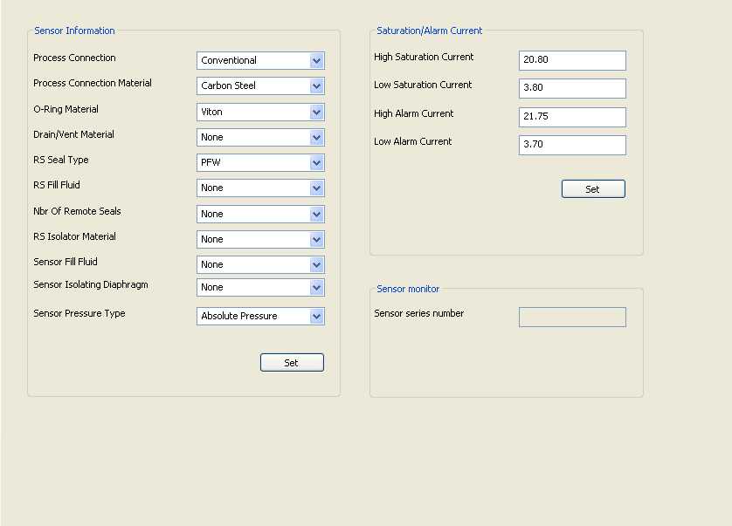
Figure 5.9 Attachment Information Tab
The saturation / alarm current setting can be used to change the current value output when the transmitter PV is in the alarm and saturation state. Range of the current settings:
limits | 4~20 mA sating current | 4~20 mA alarm current
Low | 3.7 mA ~ 3.9 mA | 3.6 mA ~ 3.8 mA
High | 20.1 mA ~ 22.9 mA | 20.2 mA ~ 23.0 mA
Notice：
- The Low alarm current value must be less than the low saturation current value;
- The High alarm current value must be higher than the high saturation current value;
- Alarm current value and saturation current value are greater than 0.1mA.

Jump Line Configuration
The HART intelligent pressure transmitter has 2 sets of hardware jumpers, as shown in Figure 5.10.The lower three points for the fault alarm current, and the upper three points for the configuration protection.

Fault Alarm Jumper Setting
The HART intelligent transmitter has the self-diagnosis function.Once the fault is detected, the intelligent transmitter will automatically output the alarm current. The alarm current mode depends on the fault alarm current on the right side of the communication card. When the jumper is inserted in the two points marked with "Hi", it is a high alarm; When the jumper is inserted in the two points marked with "Lo", it is the low alarm;

Configuration Protection Jumper Settings
The HART intelligent transmitter provides the jumper setting for the device configuration protection, namely the above configuration protection setting jumper, as shown in Figure 5.10.Conis protected when the protection setting jumper is inserted on the right, marked "WRD".The HART intelligent transmitter does not allow any change in the device configuration at this time.Changes to the device configuration are allowed when the protection setting jumper is inserted at two points on the left.
Figure 5.10 Hardware jumper of H A R T intelligent pressure transmitter

FF Type Intelligent Transmitter Configuration

Topological Connection
The FF transmitter supports a variety of network topology wiring, as shown in Figure 6.1.Figure 6.2 shows the bus connection of the FF instrument, and the two ends of the bus shall match the access terminal with the resistance to ensure the signal quality.The maximum bus length is 1,900 m and can be extended to 10 km using a repeater.
Figure 6.1 The F F network topology

Figure 6.2 F F bus connection

Functional Block
The FF intelligent pressure transmitter implements the FF standard function block, as shown in Table 6.1. Please query the documrelated of the FF protocol.
Table 6.1 Description of functional block functions
Function block name | Description
RES | Resource block used to describe characteristics of field equipment such as equipment name, manufacturer, serial number.The resource block has no input or output parameters.A device typically has only one block of resources
TRD | Transform blocks, read sensor hardware data, or write field data to the corresponding hardware.The transformation block contains information including range, sensor type, linearization, I / O data, etc
DSP | Display block for configuring the display information on the LCD screen
PID | PID function block, which performs PID control function, but also has set point adjustment, process parameter (PV) filtering, alarm, output tracking and other functions
AI | Analog input function block, used to obtain the input data of the conversion block, and can be transmitted to other function blocks, with functions such as range conversion, square root and mantissa removal
LLAG | Advance lag function block, used for feedforward control
RA | Scale function block-Implement proportional control of two input quantities
IS | Input the selection function block to select the output according to the selection items, such as the maximum, minimum, intermediate value, etc
BG | Devdeviation gain function block so that the input and output satisfy a certain linear function
SC | Signal feature function block, the same curve can describe two signal characteristics.The first output is from X to Y according on the feature curve of the block itself.The second input selection from X to Y, easy to implement the reverse function for the feature description of read variables
IT | Integrator function block, to realize the integral operation function
AR | Mathematical arithmetic blocks, allowing the selection of the most commonly used measurement mathematical function

Functional Configuration
The intelligent transmitter supports the FF configuration software, NCS4000 configuration software, NI company NI-FBUS Configurator, Rosemont company DeltaV and other general FF configuration software for configuration debugging. The following-FBUS Configurator software mainly takes NI as an example to introduce the configuration method of intelligent transmitter.

Configuration Environment
- PC machine, the operating system is Windows 2000 or Windows XP;
- NI-BUS8486, H1 bus power supply, H1 terminal matcher;
- NI-FBUS Configurator;
- Standard pressure source.

Primary Variable Zero Configuration
The transmitter adds the actual working zero point pressure value, read the PRIMARY_VALUE value of the transformation block, write the read PRIMARY_VALUE value to the COMPENSATION_VALUE variable, and click "Write". The sensor zero calibration is completed when the PRIMARY_VALUE value of the transformation block is read to zero.As shown in Figure 6.3.
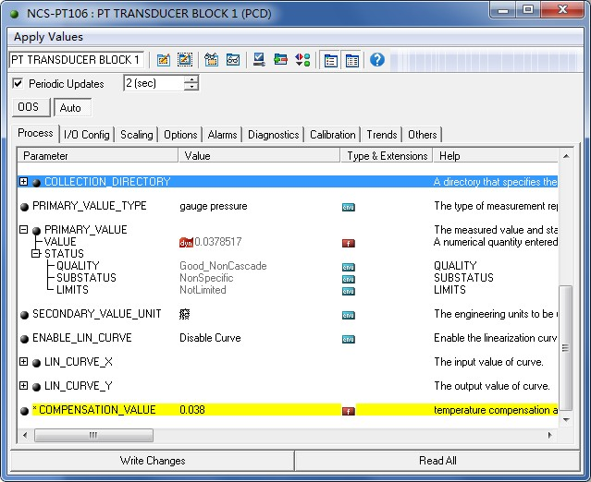
Figure 6.3 The ENABLE _ L I N _ C U R V E configuration

Lower Range Limit Configuration
The transmitter adds the actual working range lower limit pressure value, read the PRIMARY_VALUE value of the transformation block, write this value to the EU_0 parameter of the AI function block XD_SCALE parameter, and set the current sensor output lower limit of the range value of the main variable.

Upper Rang Limit Configuration
The transmitter adds the actual working range upper limit pressure value, read the PRIMARY_VALUE value of the transformation block, write this value to the EU_100 parameter of the AI function block XD_SCALE parameter, and set the current sensor output value to the range upper limit of the main variable.

Secondary-linearized Calibration
By transforming the calibration parameters LIN_CURVE_X of the block and LIN_CURVE_Y, the user can complete the secondary linearized calibration of the instrument by himself. The correction steps are as follows:
- The intelligent transmitter provides six correction point inputs, namely the parameter LIN_CURVE_Y array of the transformation block, and the user can successively write the calibrated pressure value to the array and select good units.For example, when performing a three-point interpolation calibration, the user selects 10 kPa, 20 kPa, and 30 kPa as the calibration points and writes the three values in the LIN_CURVE_Y array, as shown in Figure 6.4.
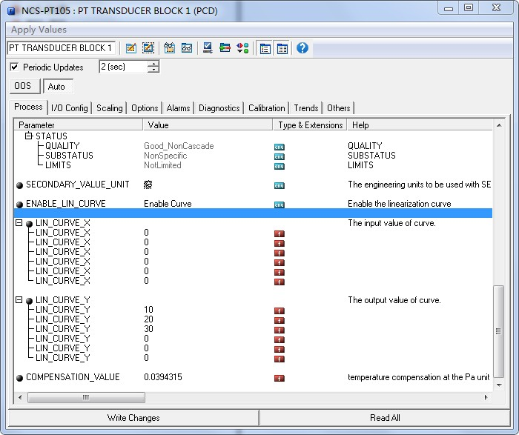
Figure 6.4 IN_CURVE_Y Configuration
- Enter the standard pressure through the ressor and open the corresponding transformation block on the configuration software, read the value of parameter PRIMARY_VALUE and write the value to the LIN_CURVE_X array. For example, write the 10.2,20.5,30.4 read in the LIN_CURVE_X array, as shown in Figure 6.5.Finish this calibration work.
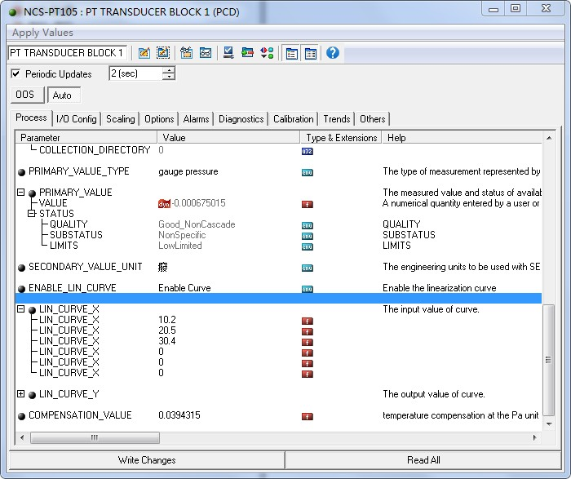
Figure 6.5 Configuration of the parameter LIN_CURVE_X
- The user sets the parameter ENABLE_LIN_CURVE of the transformation block to "Enable Curve" to make the intelligent transmitter work normally after calibration.

LCD Display Configuration
By default, the intelligent transmitter display displays the PRIMARY_VALUE parameter values for the first channel transform block, as shown in Figure 6.6.If the user needs to display additional function block parameter information, then configure it as follows (X represents 1,2,3,4, with a total of four parameters, each of which can be configured differently.Intelligent transmitter can display four different sets of different parameter information). If the parameter configuration is incorrect, the intelligent transmitter display will only display the CONFIG_ERR. Write the mode of the display block as OOS before being properly configured, and then as AUTO after the parameters are configured.This allows the configuration to take effect.
- BLOCK_TAG_X：This parameter defines the required function block name to display.For example, if a user wants to display a parameter of PT-AI1, first configure BLOCK_TAG_X and define the parameter value as PT-AI1. Note that the BLOCK_TAG_X parameter requires that the character must be 32 bytes, less than 32 bytes, which should be supplemented with space, otherwise it cannot be displayed correctly.For example, for the PT-AI1 to enter above, write the PT-AI1 in the configuration software.
- RELATIVE_INDEX_X：This parameter defines the parameter index that displays the function block. For example, display the output value of PT-AI1, defining this parameter as 8 (the PT-AI1 function block OUT parameter index is 8). For the function block parameter index, the user can refer to the protocol section of the FF Fieldbus function block.
- SUB_INDEX_X：This parameter defines the parameter subindex (if any) that displays the function block.For example, you need to display the VALUE value of the OUT parameter in the PT-AI1 function block, you need to define RELATIVE_INDEX_X as 8 and SUB_INDEX_X as 2 (the subindex of the OUT parameter VALUE item is 2).
- MNEMONIC_X：This parameter is the display parameter name, can be entered by the user at will, the number of characters does not exceed 16.
- DECI_PNT_NUMB_X：This parameter defines the display numerical accuracy.For example, you need to display 3 decimal places, defined as 3.
- ACTIVE_X ： The value of this parameter is FALSE or TRUE. After other parameters are configured, write it as TRUE. Only then can the parameters of the group be activated and the corresponding parameter information of this group can be displayed on the intelligent transmitter display.
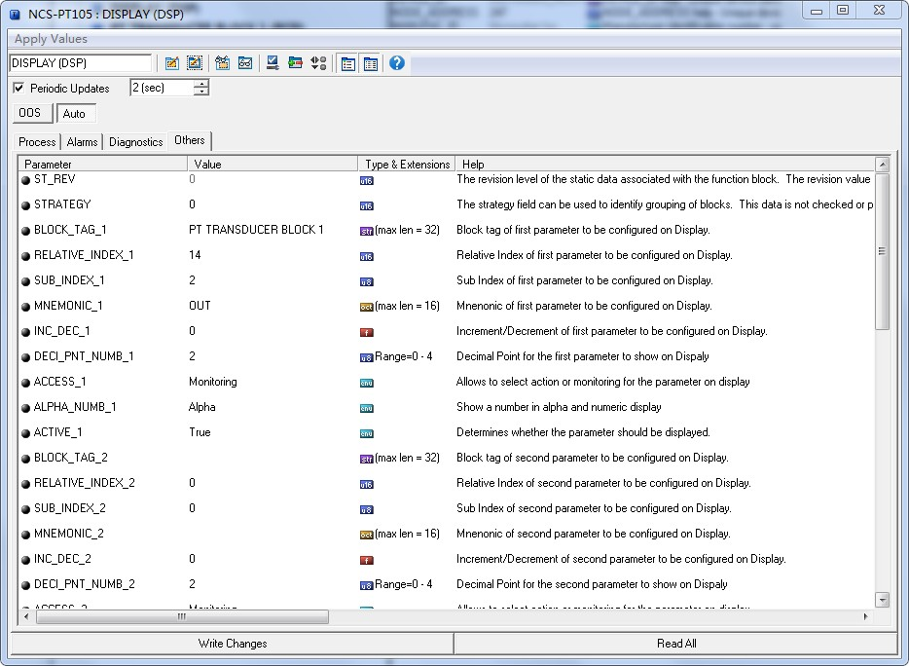
Figure 6.6 shows the parameter configuration of the block

Jump Line Configuration
The FF intelligent pressure transmitter has three hardware jumpers, as shown in Figure 6.7.
SIM jumper: simulation jumper, can achieve simulation function.
WP jumper: Write protection jumper, any write to FF intelligent pressure transmitter will be rejected, which prevents instrument data from being changed.
RST jumper: reset the jumper and restore the transmitter data to the factory state.First, the transmitter is powered off, the jumper is inserted into the RST position, the transmitter is powered on, and the transmitter is restored to the factory state.
Figure 6.7 FF intelligent pressure transmitter hardware jumper

PA Type Intelligent Transmitter Configuration

Topological Connection
- Transmitter Topology Wiring
A PROFIBUS PA network topology can have a variety of different structures, as shown in Figure 7.1.Figure 7.2 shows the bus connection of the PA instrument. The terminal resistance of the bus is connected to ensure the quality of the bus signal.The maximum length of the bus is 1900 m and can be extended to 10 km using a repeater.
Figure 7.1 The PROFIBUS PA Network Topology
Figure 7.2 PROFIBUS PA bus connection

Function Block
The PA intelligent transmitter implements the PA standard function block, as shown in Table 7.1. Please query the PROFIBUS PA row gauge.
Table 7.1 Description of functional block functions
Function Block Name | Functional Block Description
Physical Block | The Physical Function Block (PB).Specific hardware information and identification and diagnosis information are described, including device bit number, software version, hardware version, installation date, etc
Transducer Block | Transform block (TB).Separating the functional block from the input and output characteristics of the instrument, it mainly completes the calibration and linearization of the input and output data, and provides the processed data to the AI functional block through the internal channel
Analog Input Block | Analog quantity input function block (AI).The simulated process values are obtained from the transformation block through the internal channel, processed, and the appropriate measurements are provided to the main station equipment through the bus communication

Functional Configuration
For the function configuration of range setting, zero point setting, bus address and data recovery of PA type intelligent transmitter, please refer to section 4.2 "PA type intelligent transmitter field adjustment".
The parameter configuration configuration of PA intelligent transmitter follows PROFIUBS PA line gauge version 3.02.Function block parameters of the transmitter can be read and written using Siemens device management software Simatic PDM, or configured using Siemens Step7 configuration software.

Configure Environment
- PC machine, operating system of Windows XP or above;
- Siemens Step7 Configuration Software, Siemens PDM Equipment Management Software;
- DP/PA coupler or linker;
- Class 1 main station such as PLC, Class 2 main station such as CP5611 card;
- PA terminal Mater;
- Standard pressure source.

Pressure Transform Block Parameter Configuration
The transformation block separates the function block from physically proprietary I / O devices such as sensors and actuators, which relies on the implementation of the device vendor to access or control the I / O device.With access to the I / O device, the transformation block can acquire the input data or set the output data.Generally, transform blocks have functions of linearization, characterization, temperature compensation, control and exchange data.The structure of the transformed block is shown in Figure 7.3.
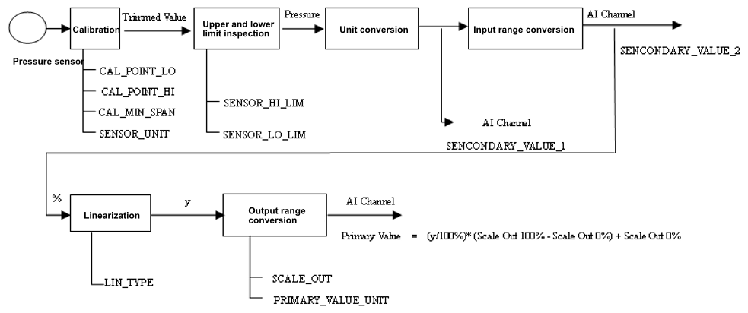
Figure 7.3 Transform block structure
The parameters of the transformation block are shown in Table 7.2:
Table 7.2 Transform block parameters
Parameter | Function Description
CAL_MIN_SPAN | Minimum step length allowed during the calibration.This minimum step size ensures a smooth calibration process, so that the highest lowest point of calibration is not too close, and the unit is specified by SENSOR_UNIT
CAL_POINT_HI | Maximum point calibration value.When calibrating the highest point, the pressure signal from the highest point is transmitted to the sensor, and then the transmitter writes the value to the parameter as the highest calibration value.The unit is specified by the SENSOR_UNIT
CAL_POINT_LO | Minpoint calibration value.When calibrating the lowest point, the pressure signal of the lowest point is transmitted to the sensor, and then the transmitter writes the value to the parameter as the lowest value for the calibration.The unit is specified by the SENSOR_UNIT
FLOW_LIN_SQRT_POINT | Flow calculation coefficient
LIN_TYPE | Linear type
LOW_FLOW_CUT_OFF | Small signal excision value
MAX_SENSOR_VALUE | Maximum sensor pressure value, as specified by SENSOR_UNIT
MIN_SENSOR_VALUE | Sensor pressure minimum, as specified by SENSOR_UNIT
MAX_TEMPERATURE | Maximum sensor temperature, measured in degrees Celsius
MIN_TEMPERATURE | Sensor temperature minimum, measured in degrees Celsius
PRIMARY_VALUE | Transmitter measurement value and status for the AI function block to use.The unit is specified by PRIMARY_VALUE_UNIT
PRIMARY_VALUE_TYPE | Transmitter measurement value type, code as following:  0: Pressure  1: Flow  2: Level  3: Volume  4-127: Reserved  > 128: Manufacturer specific  Currently, 0, 1 are supported, namely pressure value and flow value
PRIMARY_VALUE_UNIT | Transmitter measurement value engineering unit code
PROCESS_ CONNECTION_MATERIAL | Process connection material code
PROCESS_ CONNECTION_TYPE | Process Connection Material Type Code
SCALE_IN | Sensor input range, the unit is specified by SECONDARY_VALUE_1_UNIT
SCALE_OUT | Sensor output range, the unit is specified by SECONDARY_VALUE_1_UNIT
SECONDARY_VALUE_1 | Pressure value and status after correction and unit conversion are used by AI function block
SECONDARY_VALUE_1_UNIT | SECONDARY_VALUE_1 engineering unit
SECONDARY_VALUE_2 | The input range is converted into percent values for use by the AI function block
SECONDARY_VALUE_2_UNIT | SECONDARY_VALUE_2 engineering unit
SENSOR_DIAPHRAGM_ MATERIAL | Sensor diaphragm type code
SENSOR_FILL_FLUID | Sensor filler fluid type code
SENSOR_HI_LIM | Sensor physical upper limits
SENSOR_LO_LIM | Sensor physical lower limits
SENSOR_MAX_STATIC_PRESSURE | Maximum static pressure value of the sensor
SENSOR_O_RING_ MATERIAL | The O-ring type code between the sensor diaphragm and the process connection
SENSOR_SERIAL_ NUMBER | Serial number of the sensor
SENSOR_TYPE | Type of sensor
SENSOR_UNIT | Sensor raw data unit
SENSOR_VALUE | Sensor raw data value
TEMPERATURE | Sensor temperature value
TEMPERATURE_UNIT | Sensor temperature value in unit, currently fixed at degrees Celsius
TRIMMED_VALUE | Pressure value after the correction

PROFIBUS Cyclic Data Communication Configuration
The cyclic data communication of PROFIBUS DP means that the class 1 master station and the slave station exchange input and output data in the mode of master-slave polling, and the communication mode is connectionless. In each cycle, the Type 1 master station actively sends a data exchange request, while the slave station passively responds to the master station's request. The cyclic data communication is mainly used in the configuration of the slave station and the PLC master station equipment. Through the cyclic data communication, the master station PLC obtains the input data of the slave station in real time or outputs the output data to the slave station.
The circular data communication configuration of PA intelligent transmitter is basically the same as that of PROFIBUS DP slave station, but it requires the use of coupler or linker between PA bus and DP bus.
The PA intelligent transmitter cycle data comes from the output parameters of the AI function block in the device, with a total of 5 bytes, including 4 bytes of pressure value floating point data and 1 byte of status data.
The transmitter contains the AI standard function blocks and also contains an empty module.If two function blocks, select an empty module.For example, if only one AI is required, it can be configured as: an AI and an empty module.
For recurrent communication, the transmitter supports multiple identifiers.Where the AI has two identifiers, namely, the short identifier and the long identifier.The identifiers are listed below:
AI | Short identifier | 0x94
AI | Long identifier | 0x42,0x84,0x08,0x05
Cycle data communication configuration for PROFIBUS PA using Siemens Step7.
Examples of configured PA transmitters using Siemens Step7 are given below.
Open SIMATIC Manager, select the PLC master station and create a new project, see Figure 7.4.

Double-click for hardware configuration configuration
Figure 7.4 Select the PLC main station and build a new project
Double-click Hardware to punch in the HW Config software and hardware configuration.Select the GSD file for the Install GSD Install PA transmitter in the Option menu, as Figure 7.5
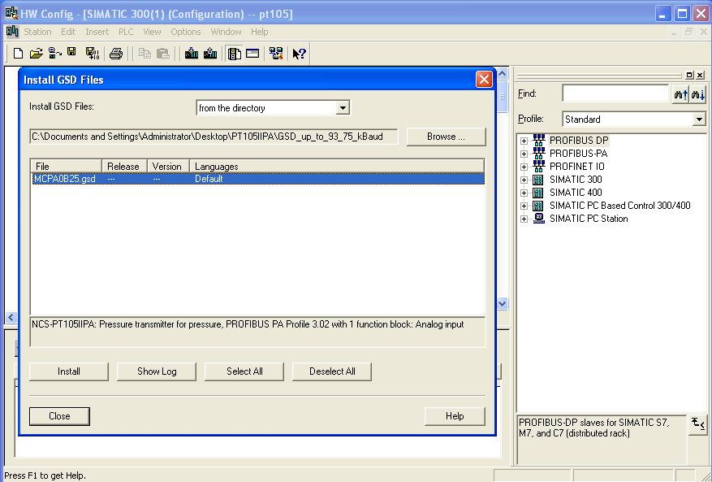
Figure 7.5 Installing the GSD file
After the GSD file is successfully installed, the newly installed PA device will be listed in the PROFIBUS-PA category in the device list on the right side of the HW Config software. Select it with the mouse and drag and drop it onto the PROFIBS DP bus, see Figure 7.6.
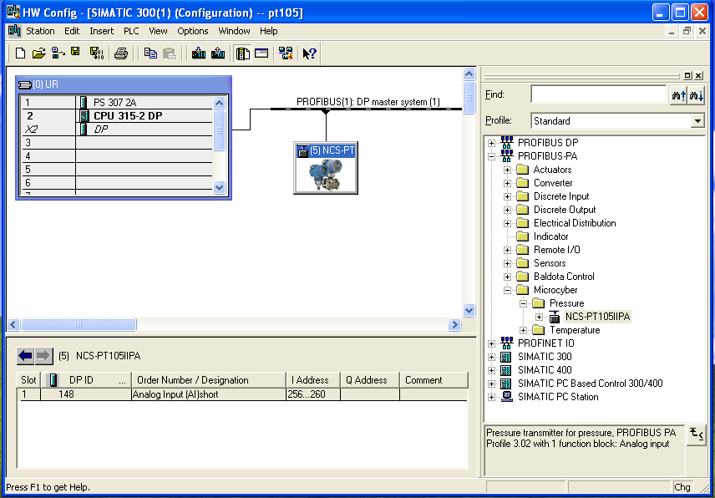
After the GSD file is installed, the PA instrument is displayed in the PROFIBS-PA directory
Figure 7.6 Drag the PA devices to the PROFIBUS DP bus
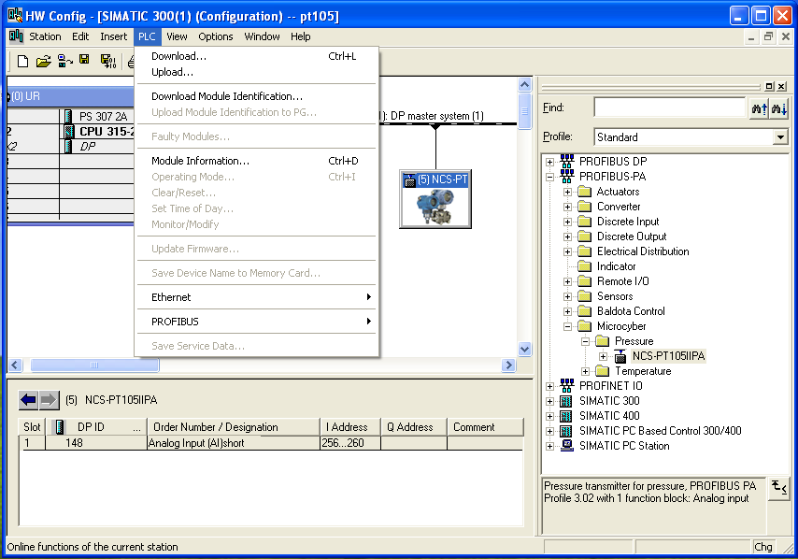
In the PLC menu, select Download to download the configuration information to the PLC master station. This completes the cyclic data communication configuration of PA instrument and main station, as Figure 7.7.

Figure 7.7 Download the configuration information to the PLC

The PROFIBUS Non-loop Data Communication Configuration
Uncyclic data communication of PROFIBUS DP refers to the connection-oriented data communication between class 2 master stations and slave stations.The data communication is performed in the non-cyclic period of the bus without affecting the cyclic data communication.Non-cyclic data is mainly the parameters of PA function block and the identification and diagnosis information of equipment.Non-cyclic data communication is mainly used in the management, diagnosis, identification, tuning and maintenance of PA equipment.
Uncyclic data communication configuration can be performed on PA instruments through Siemens equipment management software SIMATIC PDM.
Examples of SIMATIC PDM uncyclic communication configuration for PA intelligent transmitters are given below.
Before configuration, the vendor information should be piloted
Find the manufacturer.csv file under the... \ Siemens \ Step7 \ S7BIN path
Add “Microcyber;;http://www.microcyber.cn/;;;MICROCYBER;0x016C”
Open the Manage Device catalog software attached to SIMATIC PDM, then select the EDD file of PT105 and import it, as Figure 7.8.
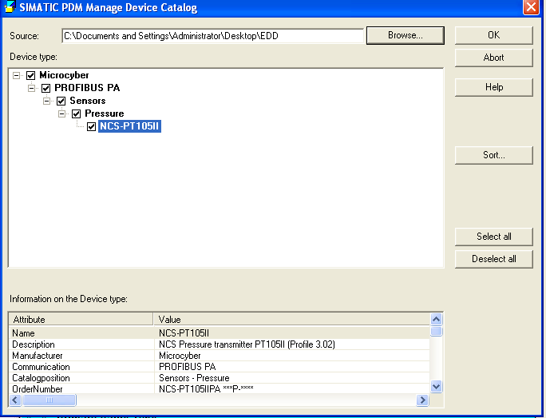
Figure 7.8 Select a Device Type
Then open the LifeList software included with SIMATIC PDM and select the Start Scan DP bus under the Scan menu, see Figure 7.9.
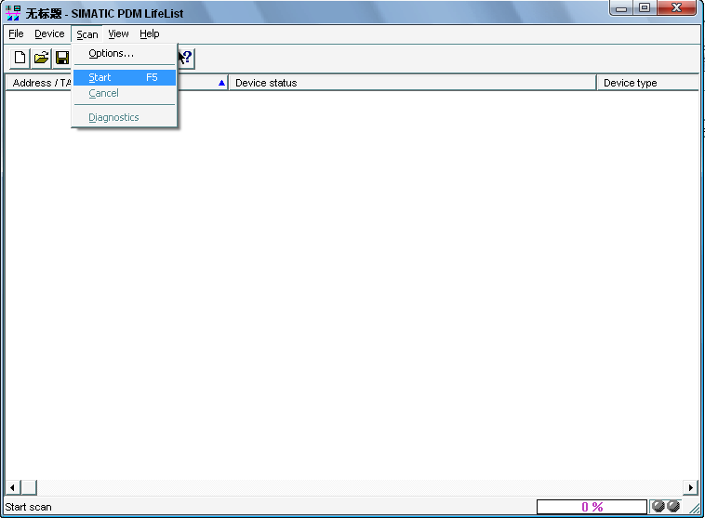
Figure 7.9 Startup of the LifeList
After scanning the bus, the slave equipment on the DP bus will be listed, showing the manufacturer ID number and some diagnostic information of the device, see Figure 7.10.
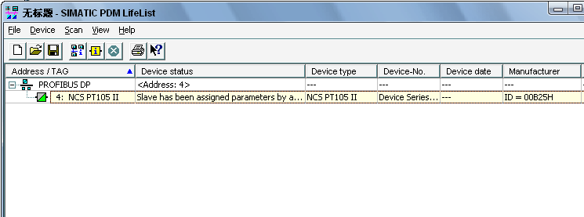
Figure 7.10 The Scan DP bus lists the PA devices
After selecting the device type, click OK, so that the non-loop data communication is configured. The parameter reading and writing of the PA instrument can be completed through the upload and download function of the PDM software, see Figure 7.11.

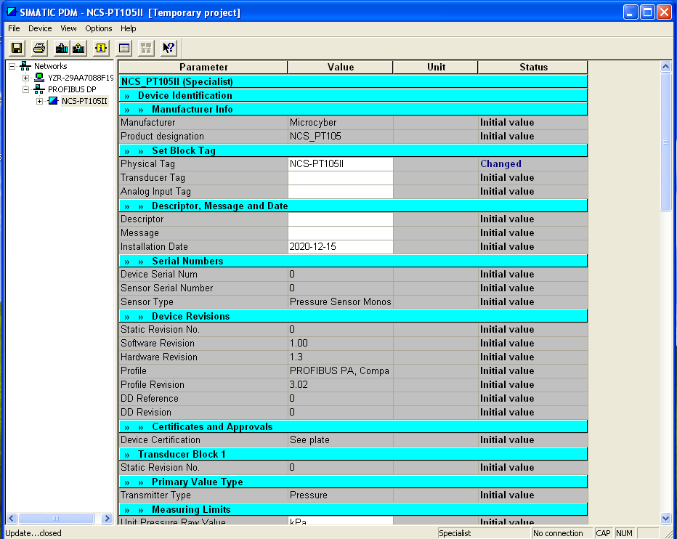
Figure 7.11 Device management with the PDM software

Jump Line Configuration
The PA intelligent pressure transmitter has three hardware jumpers, two of which can currently be used, as shown in Figure 7.12, and the SIM jumpers are not used.
RST jumper: reset jumper to restore instrument data to factory value with the same function to restore factory value data in section 5.4.The operation process is as follows: First, turn off the instrument power supply, and then insert the jumper into the RST position to repower the instrument. Then, the LCD screen is shown in Figure 7.13, indicating that the instrument data has been restored to the factory value.
Note: After using the reset jumper to restore the instrument factory value, please turn off the instrument power again, unplug the jumper at the RST, and then use the instrument normally.Otherwise, if there is a jumper at the RST, all the data will be restored to the factory value again, and the configuration information before the outage will be lost.
Figure 7.12 Hardware jumper of PA intelligent transmitter
Figure 7.13 PA intelligent transmitter recovery data to the factory value
WP jumper: write protection jumper, to realize the hardware write protection function.When the jumper is inserted into the WP position, any writing to the PA intelligent transmitter is rejected, preventing the data of the instrument from being changed

Configuration of DP Intelligent Transmitter

Function block
The DP pressure transmitter implements the functional blocks of the PA standard, see Table 8.1. For the configuration method of the function block, please refer to the PROFIBUS PA profile.
Table 8.1 Function block function description
Function block name | Function block description
Physical Block | Physical Block (PB). Describes device-specific hardware information, identification, and diagnostic information, including device tag number, software version, hardware version, installation date, etc.
Transducer Block | Transducer Block (TB). The function block is separated from the input and output characteristics of the instrument. It mainly completes functions such as calibration and linearization of input and output data, and provides the processed data to the AI function block through the internal channel.
Analog Input Block | Analog Input Block (AI). The analog process value is obtained from the transducer block via an internal channel, processed and the appropriate measured value is made available to the master device via bus communication

Function configuration

Set device address
Only using hardware DIP switches to set the device address is supported. After the address is set, the device will use the new address when it is powered on again. Setting via the SET_SLAVE_ADDRESS service is not supported.

Import GSD file
Each type of Profibus device from each manufacturer is different in functions and parameters. In order to support the "plug and play" design on the PROFIBUS bus, the device parameters (eg: manufacturer name, device name, software and hardware version, baud rate, number, input/output data) are defined in an electrical device data file Done, this file is the GSD file.
GSD file is a readable text file edited by ASCII code, it contains general parameters and definitions of relevant communication standards. Each definition entry describes the feature parameters supported by the device. Information that can be read from a GSD file through keywords and editing tools includes: device information, adjustable parameters, matching data types and corresponding data upper and lower limits.
In the NCS-PT105II(S) PROFIBUS DP GSD file, the device ID is: 0x0B25, The GSD file conforms to the PROFIBUS protocol standard and provides a concise, refined format to facilitate understanding of these parameters. In this regard, these device information can also be obtained automatically using the system configuration tool.

Configure and use Device Type Management (DTM) software
Using suitable PC software: FDT 1.2/1.2.1 application tool framework and Class II PROFIBUS master station (equipped with corresponding communication DTM), the parameter configuration and measurement value monitoring of the NCS-PT105II(S)M PROFIBUS-DP pressure transmitter can be performed through aperiodic communication.

Configuration by EDD file
Similar to using DTM, it is possible to configure the transmitter and monitor its measured values after importing the EDD file of the DP bus pressure transmitter using an EDD tool (eg, Siemens' device management software SIMATIC PDM).
Import the manufacturer information before installing the device EDD file.
Find the manufacturer.csv file under the ...\Siemens\Step7\S7BIN path.
Add "Microcyber Inc.;Microcyber Inc.;;;;Microcyber Inc.;0x016C".

Factory reset
After resetting the factory settings using the FactoryReset button in PDM, click the LoadUserDefault button in PDM to restore the configuration information to the previously saved configuration information by the user; After restoring the factory settings using dip switches and magnetic sticks, the user's saved configurations will be cleared.

WirelessHART Smart Pressure Transmitter Configuration

Debugging with configuration tool
When debugging a smart transmitter with the WirelessHART configuration tool, the required configuration environment includes a PC, a HART modem, and a matching resistor (250-550) Ω.
The debugging with the WirelessHART configuration tool mainly includes the following functions:：
1) Basic information: Configure the transmitter's label, address, date, assembly number information, etc;
2) Configuration information: Configure the main variable unit, range, damping, and other information of the transmitter;
3) Variable monitoring: monitoring the process values of the transmitter;
4) Special commands: configure the display type of the transmitter LCD, configure small signal cutoff, and save/restore related parameters functions;
5) Additional information: Configure the sensor information and sensor acquisition cycle of the transmitter;
6) Network information configuration: Configure the wireless network parameters of the transmitter, including join key, join mode, and network ID;
7) Burst configuration: Configure the wireless data update parameters of the transmitter, including Burst cycle, Burst command, Burst mode, etc;
8) Network monitoring: monitoring the wireless network status of the transmitter;

9) Other configurations: Configure the receiver sensitivity and transmission power of the transmitter RF.

Basic Information Configuration
The Basic Information tab allows you to read or modify the basic information of the smart transmitter, including Polling, Message, Description, Long Tag, Date, Assembly, Alarm, Writable, Vendor ID, Manufacturer, Device Type, Device ID, Unique ID, and Reversion, as shown in Figure 9.1. After modifying the information, you can press the "Apply" button to download it to the device. If the transmission is unsuccessful, the device information will be restored to its original content.
1) The maximum length of a Tag is 8 specified characters;
2) The Description can input up to 16 specified characters;
3) Messages can be entered with a maximum of 32 characters;
4) The range of Polling selection is 0-63;
5) The maximum length of the Assembly is 6 specified characters.
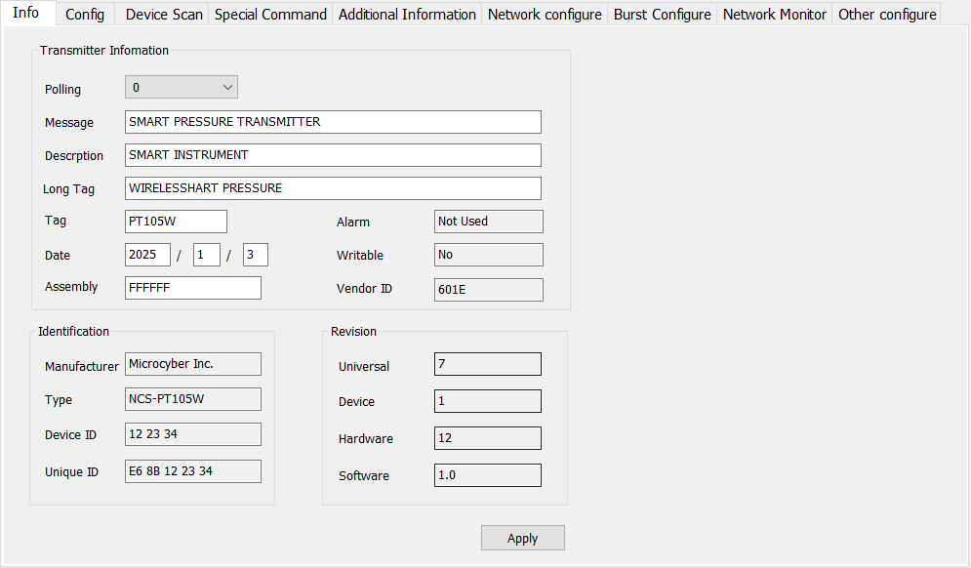
Figure 9.1 Basic Information Tab

Configuration Information Configuration
The configuration information tab allows you to read or modify the configuration information of the smart transmitter, including the values and units of the main and second variables (pressure and temperature) of the device, current values, percentages, output information of the main variables (damping value, unit, range upper limit, range lower limit, output transfer function), sensor information (serial number, upper limit, lower limit, minimum range, unit), etc., as shown in Figure 9.2.
1) Main variable unit configuration: Changes in the main variable unit directly affect variables associated with the unit, such as range limits, sensor limits, and minimum range. When modifying units, the upper and lower limits of the main variable range cannot be modified simultaneously.
2) Damping value configuration: The damping parameter range is 0-32 seconds.
3) Set the lower limit of the measuring range: take the current measured value of the main variable as the lower limit of the measuring range, and keep the measuring range unchanged (adjust the upper limit of the measuring range accordingly); If the adjustment of the upper limit of the range exceeds the upper limit of the sensor range, set the upper limit of the sensor range as the adjusted upper limit of the range, and the range will change accordingly.
4) Set upper range limit: take the current measured main variable value as the upper range limit, keep the lower range limit unchanged, and change the range accordingly; If the adjusted range upper limit exceeds the sensor range upper limit, set the sensor range upper limit to the adjusted range upper limit.
5) Zero point of the main variable: Correct the offset of the zero point of the main variable caused by the installation position.
6) Calibration range: After range migration, calibrate the upper and lower limits of the range. The calibration process is as follows:
a. Add the standard range lower limit pressure to the transmitter. After the pressure stabilizes, click "Read" and the calibration data will be displayed in "Correction Value". Click "Lower Limit Calibration" and the actual pressure value will be the range lower limit pressure value.
b.Add the standard range upper limit pressure to the transmitter. After the pressure stabilizes, click "Read" to display the calibration data in "Correction Value". Click "Upper Limit Calibration", and the actual pressure output will be the range upper limit pressure value.
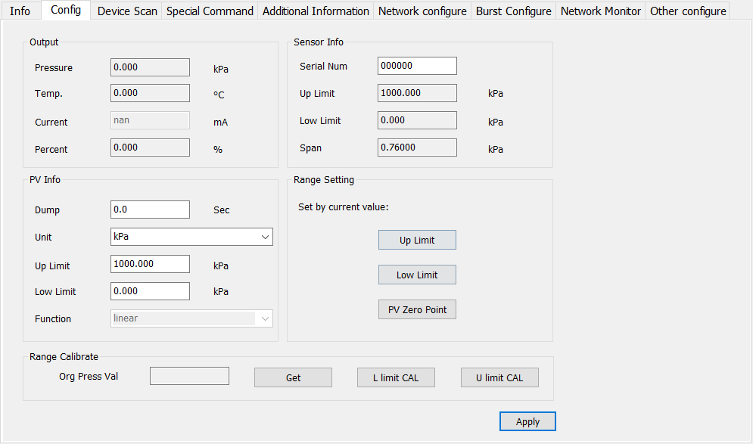
Figure 9.2 Configuration Information Tab

Variable Monitoring
The variable monitoring tab allows monitoring of the values of the PV (pressure), SV (sensor temperature), TV (battery voltage), and QV (MCU temperature), as shown in Figure 9.3.
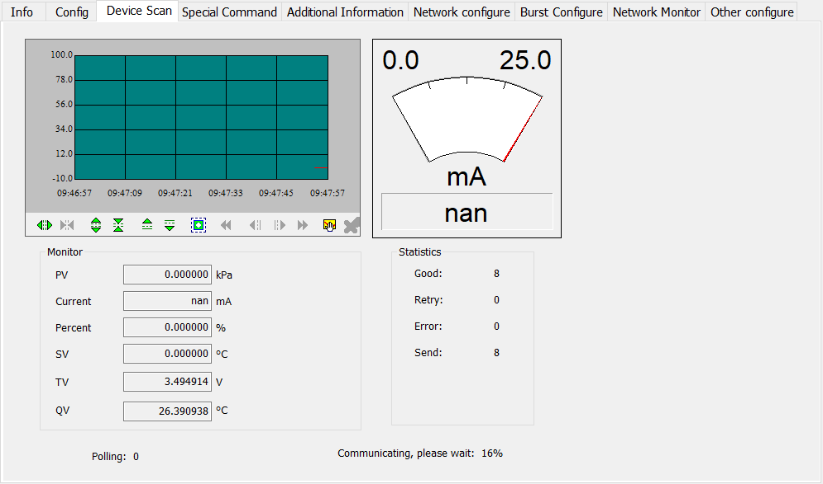
Figure 9.3 Variable Monitoring Tab

Special Commands
The special command tab allows for reading or modifying functions such as LCD display type, LCD operation mode, small signal cutoff, and saving/restoring related parameters, as shown in Figure 9.4.
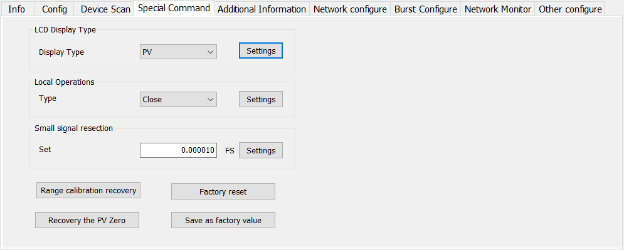
Figure 9.4 Special Command Tab
This tab contains:
1) LCD display type: used to set the main variables displayed on the transmitter LCD head. It can be set to display the main variable value, display the second variable value, display the battery voltage value, display the percentage, and display the main variable and battery voltage value alternately.
2) Local operation: used to set the display mode of the transmitter LCD head. Can be set as: off, cycle on, on.
3) Small signal resection: The percentage range of small signal resection is 0.0~0.005.
4) Data saving and recovery: Restore range calibration and zero calibration data to default values, save current configuration data to factory values or restore previously saved configuration data.

Additional Information
The additional information tab allows you to read or modify transmitter related material information and sensor acquisition cycles, as shown in Figure 9.5. The sensor acquisition cycle is set within the range of 1-3600 seconds.
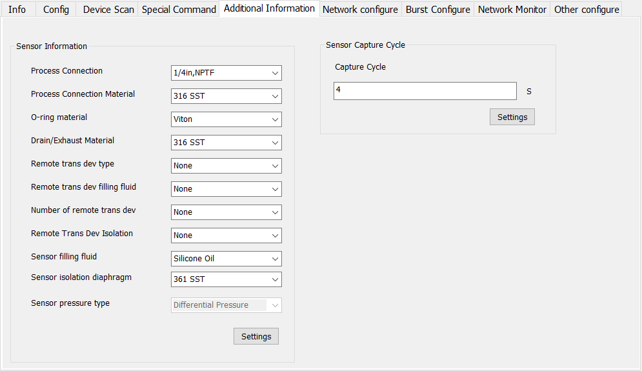
Figure 9.5 Additional Information Tab

Network Information Configuration
The Network Information Configuration tab allows you to read or modify wireless network parameters, including join key, join mode, and network ID, as shown in Figure 9.6. To join a wireless network, the device needs to configure the join mode as Join now, and the join key and network ID should be consistent with the gateway parameters of the network to be joined.
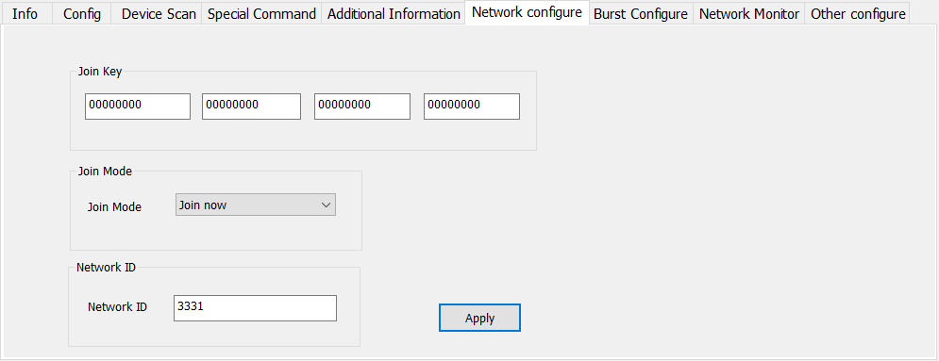
Figure 9.6 Network Information Configuration Tab

Burst Configuration
The Burst configuration tab allows you to read or modify Burst parameters, including Burst messages, Burst cycles, device variables, Burst commands, and Burst modes, as shown in Figure 9.7.
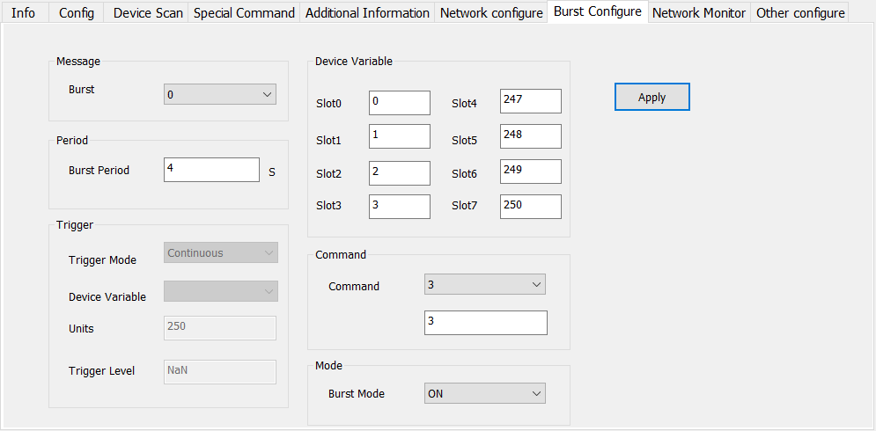
Figure 9.7 Burst Configuration Tab
- Burst messages support 4 types of messages from 0 to 3, and the 4 message modes are independent of each other.
- The Burst cycle supports 1s, 2s, 4s, 8s, 16s, 32s, 60s~3600s.
- The device variable is only activated when the Burst command is set to 9, and the variable transmitted by Burst can be modified. The command code supports six types of commands: 1, 2, 3, 9, 33, and 48.
- Burst mode is ON/OFF. After the device is connected to the network, it needs to wait for a certain delay in startup time to enable Burst mode.

Network Monitor
The network monitor tab allows you to view the device's network access status, as shown in Figure 9.8.
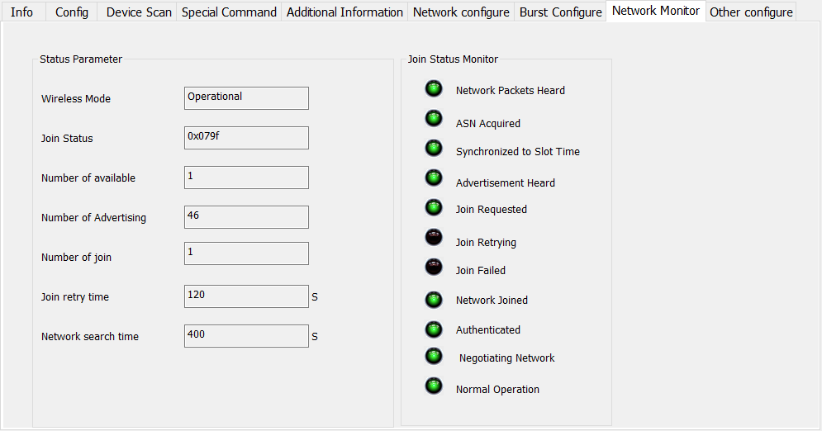
Figure 9.8 Network Monitor Tab
The normal network access process takes 2-5 minutes, and the duration of network access depends on the number of network devices in the same network and the distance between the devices and the gateway. When the wireless mode in the status parameter bar displays "Operational", the device has successfully connected to the network. At this time, entering the gateway page, you can see that the device has already connected to the network.

Other Configuration
The RF receiver sensitivity and transmission power can be read or modified through other configuration tab, as shown in Figure 9.9.
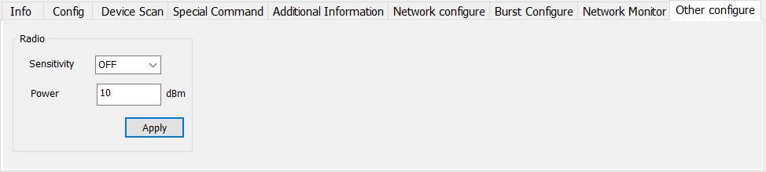
Figure 9.9 Other Configuration Tab
- Receiving sensitivity. When the distance between the gateway and the transmitter is too far or the RF signal is poor, the receiving sensitivity can be turned on to improve the RF receiving capability of the transmitter.
- Transmission power. The default transmission power of the transmitter is 10dBm, which can be modified to a maximum of 13dBm to enhance the transmitter's RF transmission capability.
Note: The above operation will result in additional energy consumption.

DD Menu Tree
Figure 9.10 DD Menu Tree-overview
Figure 9.11 DD Menu Tree-details

Maintainence
- Simple maintenance
Number | Display | Reason | Methods
1 | Output current value is 0 | a. power failure  b. wire cutting | a. modify power  b. check wire
2 | HART intelligent transmitter output current value exceeds limit | Failure connection between the sensor and the circuit board. | Check the connection.
3 | HART intelligent transmitter current fixed on 4mA，add pressure the output has no change. | a. instrument in multi-point mode  b. leakage | a. modify slaves address in single mode  b. check the connection of gas pipe
4 | Intelligent transmitter communication failure | a. connection failure  b. multi-mode | a. check the wire loop  b. check net
- Daily maintenance：Only clean.
- Failing repair：Please return it back.
- Note: Products that have passed the explosion-proof inspection are not allowed to arbitrarily replace and modify the components and structures that affect the explosion-proof performance.

Technical Specifications

Basic Parameter
Measure object | liquid、gas、stream
Power | FF/PA | (9～32) VDC/(9～17.5)VDC (Intrinsically Safe)
Power | HART | (11.9～42)VDC/(11.9～30)VDC (Intrinsically Safe)
Power | DP | 10～30VDC
Power | WirelessHART | 3.6VDC
Fieldbus protocol | 2-wire, (4～20)mA+HART, FF, PA WirelessHART
Load resistant | (0～1500)Ω (common)  (230～1100)Ω (with HART)
Insulating strength | Between the terminal and the housing: 500 Vrms
Display | Optional 6 bits digital number or 5 bits characters LCD display
Temperature scale | Work temperature:  (-40～85) ℃ (None explosion-proof, no display)  (-30～70) ℃ (None explosion-proof, display)  (-30～60) ℃ (Explosion-proof grade Ex ia IIC T4 Ga)  (-40～60) ℃ (Explosion-proof grade Ex d IIC T4/T6 Gb)
Media temperature | (-40～120) ℃ (silicone oil)
Humidity range | (5～95)%RH
Start time* | ≤8s (HART、WirelessHART)  ≤12s (PA、DP)  ≤13s (FF)
Quiescent current (FF、PA)* | ≤14mA
Battery characteristics(WirelessHART)* | 2 * 19mAh/3.6V D-type battery  21 ℃, LCD off, 3 years @ 60 seconds
Refresh time | 0.35s
Dump adjusting | Time constant 0～32 seconds
Change of cavity | < 0.16 cm³
Ex type | Ex ia, Ex d
Protection grade | IP65/IP67
Explosion-proof performance | DA：Ex d IIC T6 Gb  DC：Ex d IIC T4 Gb  IC：Ex ia IIC T4 Ga
Protection class | No explosion-proof type: the enclosure protection grade reaches IP65;  Explosion-proof type: the enclosure protection grade reaches IP67;  Intrinsically safe: the enclosure protection level reaches IP65.
Electromagnetic compatibility | Comply with the immunity requirements of industrial places in GB/T 18268.1  Comply with the harassment requirements for Class A equipment in GB 9254
* Start time: The current is updated to the main variable pressure value (HART、WirelessHART), and the liquid crystal displays the main variable pressure value (FF, PA, DP).
** Quiescent current accuracy is 1%.
* For IP67 protection, when the electrical interface is NPT threaded, it is necessary to use sealant or tape for sealing.

Performance Index

NCS-PT105IIM differential pressure transmitter performance index
- Range and range limit
Nominal range | Range of measurement | Lower range limit | Upper range limit | Static pressure range | One-way high-voltage end overload | One-way low-voltage end overload
3kPa | 100Pa~3kPa | -3Kpa | 3kPa | 4MPa | 4MPa | 4MPa
6kPa | 200Pa~6kPa | -6KPa | 6kPa | 4MPa | 4MPa | 4MPa
40kPa | 400Pa~40kPa | -40kPa | 40kPa | 25MPa | 10MPa | 10MPa
250kPa | 2.5kPa~250kPa | -250kPa | 250kPa | 25MPa | 10MPa | 10MPa
1MPa | 10kPa~1MPa | -500kPa | 1MPa | 25MPa | 10MPa | 10MPa
3MPa | 30kPa~3MPa | -500kPa | 3MPa | 25MPa | 10MPa | 3MPa
10Mpa | 100kPa~10MPa | -500kPa | 10Mpa | 25MPa | 10MPa | 3MPa
Set the high and low limit requirements：The low and high limit values are taken within the upper range.
When | URV | ≥ | LRV |, | URV | ≥ minimum range must be met; when | URV | ≤ | LRV |, | LRV | ≥ minimum range must be concealed
Overpressure limit value: Depending on the pressure value of the weakest component, which is the maximum pressure of the sensor, not the maximum pressure of the product itself.
- Reference accuracy
Range | Reference accuracy (including linearity, hysteresis, and repeatability)
250kPa、1MPa、3MPa、10MPa | ±0.075%SPAN  For ranges less than 10:1, accuracy: ± (0.0075 * TD)% * SPAN
3kPa、6kPa、40kPa | ±0.075%SPAN  For ranges less than 5:1, accuracy:±(0.015*TD)%*SPAN
The square root output accuracy is 1.5 times that of the above linear reference accuracy
Note 1, TD (Turn down) is the range ratio, when | URV | ≥ | LRV |, TD=URL/ | LRV |
When | URV | ≤ | LRV |, TD=URL/ | LRV |
Note 2: SPAN refers to range difference: SPAN=|URV-LRV|
- Ambient temperature influence
Total impact for every 10℃ within the-40-85℃ range | ±0.075%URL
- Static pressure influence
Range ≤ 6kPa | ± 0.1% upper range limit/4MPa
Range ≥ 40kPa | ± 0.1% upper range limit/10Mpa
- Power supply influence
The zero and range changes shall not exceed the ± 0.005% upper range limit / V
- Stability
Annual stability: ± 0.2% URL /5 years

NCS-PT105IIM high static pressure differential pressure transmitter performance index
- Range and range limit
Nominal range | Range of measurement | Lower range limit | Upper range limit | Static pressure range | One-way high-voltage end overload | One-way low-voltage end overload
3kPa | 100Pa~3kPa | -3Kpa | 3kPa | 16MPa | 16MPa | 16MPa
6kPa | 200Pa~6kPa | -6Kpa | 6kPa | 25Mpa | 25Mpa | 16Mpa
40kPa | 400Pa~40kPa | -40kPa | 40kPa | 40Mpa | 25Mpa | 16Mpa
250kPa | 2.5kPa~250kPa | -250kPa | 250kPa | 40Mpa | 25Mpa | 16Mpa
1MPa | 10kPa~1MPa | -500kPa | 1MPa | 40Mpa | 25Mpa | 16Mpa
3MPa | 30kPa~3MPa | -500kPa | 3MPa | 40Mpa | 25Mpa | 3Mpa
10Mpa | 100kPa~10Mpa | -500kPa | 10Mpa | 40Mpa | 25Mpa | 3Mpa
Set the high and low limit requirements：The low and high limit values are taken within the upper range.
When | URV | ≥ | LRV |, | URV | ≥ minimum range must be met; when | URV | ≤ | LRV |, | LRV | ≥ minimum range must be concealed
Overpressure limit value: Depending on the pressure value of the weakest component, which is the maximum pressure of the sensor, not the maximum pressure of the product itself.
- Reference accuracy
Range | Reference accuracy (including linearity, hysteresis, and repeatability)
250kPa、1MPa、3MPa、10MPa | ±0.075%SPAN  For ranges less than 10:1, accuracy: ± (0.0075 * TD)% * SPAN
3kPa、6kPa、40kPa | ±0.075%SPAN  For ranges less than 5:1, accuracy:±(0.015*TD)%*SPAN
The square root output accuracy is 1.5 times that of the above linear reference accuracy
Note 1, TD (Turn down) is the range ratio, when | URV | ≥ | LRV |, TD=URL/ | LRV |
When | URV | ≤ | LRV |, TD=URL/ | LRV |
Note 2: SPAN refers to range difference: SPAN=|URV-LRV|
- Ambient temperature influence
Total impact for every 10℃ within the-40-85℃ range | ±0.075%URL
- Static pressure influence
Range ≤ 6kPa | ± 0.1% upper range limit/4MPa
Range ≥ 40kPa | ± 0.1% upper range limit/10Mpa
- Power supply influence
The zero and range changes shall not exceed the ± 0.005% upper range limit / V
- Stability
Annual stability: ± 0.2% URL /5 years

NCS-PT105IIM Absolute pressure transmitter performance index
- Range and range limit
Nominal range | Range of measurement | Lower range limit | Upper range limit | Overload
40kPa | 20kPa~40kPa | 0kPa | 40kPa | 16MPa
250kPa | 50kPa~250kPa | 0kPa | 250kPa | 16MPa
1MPa | 200kPa~1MPa | 0kPa | 1MPa | 16MPa
10MPa | 1Mpa~10MPa | 0kPa | 10MPa | 20MPa
40MPa | 4MPa~40MPa | 0KPa | 40MPa | 80MPa
Set the high and low limit requirements：The low and high limit values are taken within the upper range. When URV-LRV ≥ minimum range
Overpressure limit value: It depends on the pressure value of the weakest part with the pressure bearing capacity. This overload pressure is the maximum pressure that the sensor can bear, not the maximum pressure that the product itself can bear.
- Reference accuracy
Range | Reference accuracy (including linearity, hysteresis, and repeatability)
250kPa、1MPa、10MPa、40MPa | ±0.075%SPAN  For ranges less than 5:1, accuracy: ± (0.015 * TD)% * SPAN
40kPa | ±0.075%SPAN  For ranges less than 2:1, accuracy:±(0.0375*TD)%*SPAN
The square root output accuracy is 1.5 times that of the above linear reference accuracy
Note 1, TD (Turn down) is the range ratio, when | URV | ≥ | LRV |, TD=URL/ | LRV |
When | URV | ≤ | LRV |, TD=URL/ | LRV |
Note 2: SPAN refers to range difference: SPAN=|URV-LRV|
- Ambient temperature impact
Total impact for every 10℃ within the-40-85℃ range | ±0.075%URL
- Power supply influence
The zero and range changes shall not exceed the ± 0.005% upper range limit / V
- Stability
Annual stability: ± 0.2% URL /5 years

NCS-PT105IIM Gauge pressure transmitter performance index
- Range and range limit
Nominal range | Range of measurement | Lower range limit | Upper range limit | Overload
3kPa | 100Pa~3kPa | -3Kpa | 3kPa | 10MPa
6kPa | 200Pa~6kPa | -6kPa | 6kPa | 10MPa
40kPa | 400Pa~40kPa | -40kPa | 40kPa | 10MPa
250kPa | 2.5kPa~250kPa | -100kPa | 250kPa | 10MPa
1MPa | 10kPa~1MPa | -100kPa | 1MPa | 10MPa
3MPa | 30kPa~3MPa | -100kPa | 3MPa | 10MPa
10MPa | 100kPa~10MPa | -100kPa | 10MPa | 20MPa
20MPa | 200kPa~20MPa | -100kPa | 20MPa | 40MPa
40MPa | 400kPa~40MPa | -100kP | 40MPa | 80MPa
Set the high and low limit requirements：The low and high limit values are taken within the upper range. When URV-LRV ≥ minimum range
Overpressure limit value: It depends on the pressure value of the weakest part with the pressure bearing capacity. This overload pressure is the maximum pressure that the sensor can bear, not the maximum pressure that the product itself can bear.
- Reference accuracy
Range | Reference accuracy (including linearity, hysteresis, and repeatability)
250kPa、1MPa、3MPa、10MPa、40MPa | ±0.075%SPAN  For ranges less than 10:1, accuracy: ± (0.005 * TD)% * SPAN
3kPa、6kPa、40kPa | ±0.075%SPAN  For ranges less than 5:1, accuracy:±(0.015*TD)%*SPAN
The square root output accuracy is 1.5 times that of the above linear reference accuracy
Note 1, TD (Turn down) is the range ratio, when | URV | ≥ | LRV |, TD=URL/ | LRV |
When | URV | ≤ | LRV |, TD=URL/ | LRV |
Note 2: SPAN refers to range difference: SPAN=|URV-LRV|
- Ambient temperature impact
Total impact for every 10℃ within the-40-85℃ range | ±0.075%URL
- Power supply influence
The zero and range changes shall not exceed the ± 0.005% upper range limit / V
- Stability
Annual stability: ± 0.2% URL /5 years

NCS-PT105IISM Gauge pressure transmitter performance index
- Range and range limit
Nominal range | Range of measurement | Lower range limit | Upper range limit | Overload
3kPa | 150Pa~3kPa | -3Kpa | 3kPa | 400KPa
6kPa | 200Pa~6kPa | -6Kpa | 6kPa | 400KPa
40kPa | 2kPa~40kPa | -40kPa | 40kPa | 1MPa
250kPa | 12.5kPa~250kPa | -100kPa | 250kPa | 4MPa
1MPa | 50kPa~1MPa | -100kPa | 1MPa | 6MPa
3MPa | 150kPa~3MPa | -100kPa | 3MPa | 15MPa
10MPa | 500kPa~10MPa | -100kPa | 10MPa | 20MPa
Set the high and low limit requirements：The low and high limit values are taken within the upper range. When URV-LRV ≥ minimum range
Overpressure limit value: It depends on the pressure value of the weakest part with the pressure bearing capacity. This overload pressure is the maximum pressure that the sensor can bear, not the maximum pressure that the product itself can bear.
- Reference accuracy
Range | Reference accuracy (including linearity, hysteresis, and repeatability)
250kPa、1MPa、3MPa、10MPa | ±0.075%SPAN  For ranges less than 10:1, accuracy: ± (0.0075 * TD)% * SPAN
3kPa、6kPa、40kPa | ±0.075%SPAN  For ranges less than 5:1, accuracy:±(0.015*TD)%*SPAN
The square root output accuracy is 1.5 times that of the above linear reference accuracy
Note 1, TD (Turn down) is the range ratio, when | URV | ≥ | LRV |, TD=URL/ | LRV |
When | URV | ≤ | LRV |, TD=URL/ | LRV |
Note 2: SPAN refers to range difference: SPAN=|URV-LRV|
- Ambient temperature impact
Total impact for every 10℃ within the-40-85℃ range | ±0.075%URL
- Power supply influence
The zero and range changes shall not exceed the ± 0.005% upper range limit / V
- Stability
Annual stability: ± 0.2% URL /5 years

NCS-PT105IISM Absolute pressure transmitter performance index
- Range and range limit
Nominal range | Range of measurement | Lower range limit | Upper range limit | Overload
40kPa | 20kPa~40kPa | 0 | 40kPa | 1MPa
250kPa | 50kPa~250kPa | 0 | 250kPa | 4MPa
1MPa | 200kPa~1MPa | 0 | 1MPa | 6MPa
10MPa | 1Mpa~10MPa | 0 | 10MPa | 20MPa
40MPa | 4Mpa~40MPa | 0 | 40MPa | 80MPa
Set the high and low limit requirements：The low and high limit values are taken within the upper range. When URV-LRV ≥ minimum range
Overpressure limit value: It depends on the pressure value of the weakest part with the pressure bearing capacity. This overload pressure is the maximum pressure that the sensor can bear, not the maximum pressure that the product itself can bear.
- Reference accuracy
Range | Reference accuracy (including linearity, hysteresis, and repeatability)
250kPa、1MPa、10MPa、40MPa | ±0.075%SPAN  For ranges less than 10:1, accuracy: ± (0.015 * TD)% * SPAN
40kPa | ±0.075%SPAN  For ranges less than 5:1, accuracy:±(0.0375*TD)%*SPAN
The square root output accuracy is 1.5 times that of the above linear reference accuracy
Note 1, TD (Turn down) is the range ratio, when | URV | ≥ | LRV |, TD=URL/ | LRV |
When | URV | ≤ | LRV |, TD=URL/ | LRV |
Note 2: SPAN refers to range difference: SPAN=|URV-LRV|
- Ambient temperature impact
Total impact for every 10℃ within the-40-85℃ range | ±0.075%URL
- Power supply influence
The zero and range changes shall not exceed the ± 0.005% upper range limit / V
- Stability
Annual stability: ± 0.2% URL /5 years

Physical properties

NCS-PT105IIM Intelligent pressure transmitter
Electrical connection | 1/2-14 NPT female
Process connection | 1/4-18 NPT female
Structural materials | MOC：316 stainless steel, Hastelloy C, Monel or tantalum;  Bleed/drain valve: 304 stainless steel, 316 stainless steel;  Flange and connector: 304 stainless steel, 316 stainless steel;  O-ring: Nitrile rubber, fluorine rubber;  Filled liquid: silicon oil or fluorocarbon oil;  Bolt：zinc plating carbon steel;  (The material above should be selected at order, if has other requirement, please report in advance)  Housing: low copper aluminum alloy;  Coating: Polyester epoxy resin.

NCS-PT105IISM Intelligent pressure transmitter
Electrical connection | 1/2-14 NPT female

Size of diaphragm
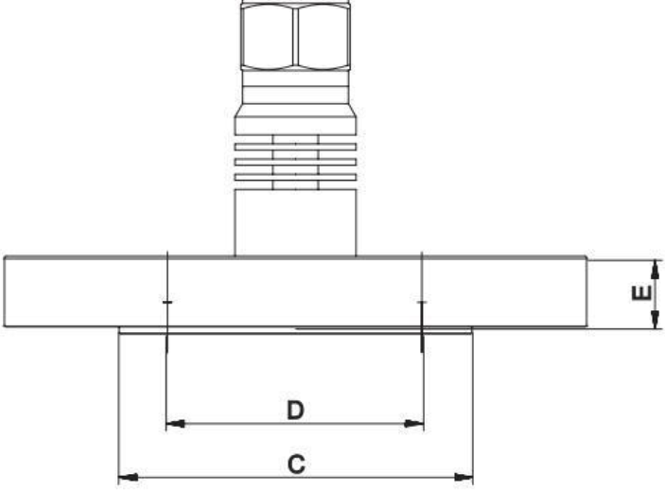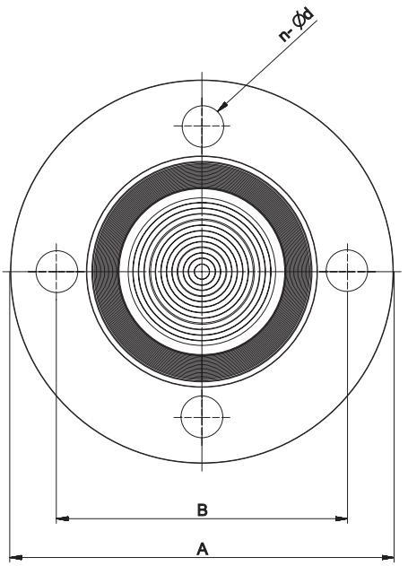
Figure 11.1 Size of diaphragm

DN50 size table
Class | A | B | C | D（Inner diameter of gasket contact surface） | E | Number of bolts(n) | Diameter of bolt hole (d)
ANSI 150 | 150 | 120.7 | 92.1 | 61 | 17.5 | 4 | 18
ANSI 300 | 165 | 127 | 92.1 | 61 | 20.7 | 8 | 18
ANSI 600 | 165 | 127 | 92.1 | 61 | 25.4 | 8 | 18
DIN PN 10/16 | 165 | 125 | 102 | 61 | 16 | 4 | 18
DIN PN 25/40 | 165 | 125 | 102 | 61 | 18 | 4 | 18
DIN PN 64 | 180 | 135 | 102 | 61 | 24 | 4 | 22
DIN PN 100 | 195 | 145 | 102 | 61 | 26 | 4 | 26

DN80 size table
Class | A | B | C | D（Inner diameter of gasket contact surface） | E | Number of bolts(n) | Diameter of bolt hole (d)
ANSI 150 | 190 | 152.4 | 127 | 89 | 22.3 | 4 | 18
ANSI 300 | 210 | 168.3 | 127 | 89 | 27 | 8 | 22
ANSI 600 | 210 | 168.3 | 127 | 89 | 31.8 | 8 | 22
DIN PN 10/16 | 200 | 160 | 138 | 89 | 18 | 8 | 18
DIN PN 25/40 | 200 | 160 | 138 | 89 | 22 | 8 | 18
DIN PN 64 | 215 | 170 | 138 | 89 | 26 | 8 | 22
DIN PN 100 | 230 | 180 | 138 | 89 | 30 | 8 | 26

DN100 size table
Class | A | B | C | D（Inner diameter of gasket contact surface） | E | Number of bolts(n) | Diameter of bolt hole (d)
ANSI 150 | 230 | 190.5 | 157.2 | 115 | 22.3 | 8 | 18
ANSI 300 | 255 | 200 | 157.2 | 115 | 30.2 | 8 | 22
ANSI 600 | 275 | 215.9 | 157.2 | 115 | 38.1 | 8 | 26
DIN PN 10/16 | 220 | 180 | 158 | 115 | 18 | 8 | 18
DIN PN 25/40 | 235 | 190 | 162 | 115 | 22 | 8 | 22
DIN PN 64 | 250 | 200 | 162 | 115 | 28 | 8 | 26
DIN PN 100 | 265 | 210 | 162 | 115 | 34 | 8 | 30

- NCS-PT105IIM Intelligent Pressure Transmitter Selection
Model |  | Name
NCS-PT105IIMSG |  | Gauge pressure transmitter
NCS-PT105IIMSA |  | Absolute pressure transmitter
NCS-PT105IIMSD |  | Differential pressure transmitter
NCS-PT105IIMSH |  | High static pressure differential pressure transmitter
 |  | Code |  | Range |  |  |  | Lower range limit |  |  |  |  | Upper range
 |  |  |  |  |  |  |  | SG |  | SA | SD/SH |  | Upper range
 |  | 1 |  | 3Kpa |  |  |  | -3Kpa |  | No such range | -3Kpa |  | 3Kpa
 |  | 2 |  | 6kPa |  |  |  | -6kPa |  | No such range | -6Kpa |  | 6kPa
 |  | 3 |  | 40kPa |  |  |  | -40kPa |  | 0kPa | -40kPa |  | 40kPa
 |  | 4 |  | 250kPa |  |  |  | -100kPa |  | 0kPa | -250kPa |  | 250kPa
 |  | 5 |  | 1MPa |  |  |  | -100kPa |  | 0kPa | -500kPa |  | 1MPa
 |  | 6 |  | 3MPa |  |  |  | -100kPa |  | No such range | -500kPa |  | 3MPa
 |  | 7 |  | 10MPa |  |  |  | -100kPa |  | 0kPa | -500kPa |  | 10Mpa
 |  | 8 |  | 20MPa |  |  |  | -100kPa |  | 0kPa | No such range |  | 20Mpa
 |  | 9 |  | 40MPa |  |  |  | -100kPa |  | 0KPa | No such range |  | 40Mpa
 |  | Note |  | When high static pressure, differential pressure and gauge pressure (mileage>25MPa) are selected, high pressure clamps will be used, and the screws and bolts that fix the clamps are made of carbon steel.
 |  |  |  | Code |  | Communication protocol
 |  |  |  | H |  | HART
 |  |  |  | P |  | PA
 |  |  |  | F |  | FF
 |  |  |  | D |  | DP
 |  |  |  | W |  | WirelessHART
 |  |  |  |  |  | Code |  | Structure material (Filled liquid: silicon oil)
 |  |  |  |  |  |  |  | Flange, drain/vent valve |  |  |  | MOC of sensor
 |  |  |  |  |  | 22 |  | 316 stainless steel |  |  |  | 316L stainless steel
 |  |  |  |  |  | 23 |  | 316 stainless steel |  |  |  | Hastelloy C
 |  |  |  |  |  | 24 |  | 316 stainless steel |  |  |  | Monel alloy
 |  |  |  |  |  | 25 |  | 316 stainless steel |  |  |  | Tantalum
 |  |  |  |  |  | 26 |  | 316 stainless steel |  |  |  | Titanium
 |  |  |  |  |  | 32 |  | 304 stainless steel |  |  |  | 316L stainless steel
 |  |  |  |  |  | 33 |  | 304 stainless steel |  |  |  | Hastelloy C
 |  |  |  |  |  | 34 |  | 304 stainless steel |  |  |  | Monel alloy
 |  |  |  |  |  | 35 |  | 304 stainless steel |  |  |  | Tantalum
 |  |  |  |  |  | 42 |  | SS2205 stainless steel |  |  |  | 316L stainless steel
 |  |  |  |  |  | 43 |  | SS2205 stainless steel |  |  |  | Hastelloy C
 |  |  |  |  |  | 44 |  | SS2205 stainless steel |  |  |  | Monel alloy
 |  |  |  |  |  | 45 |  | SS2205 stainless steel |  |  |  | Tantalum
 |  |  |  |  |  |  |  |  | Code | Options
 |  |  |  |  |  |  |  |  | M₅ | LCD display
 |  |  |  |  |  |  |  |  | IC | Ex ia IIC T4 Ga
 |  |  |  |  |  |  |  |  | T₂ | Three-Valve Manifold, 316 Stainless Steel
 |  |  |  |  |  |  |  |  | B₁ | Plate bending bracket
NCS-PT105IIMBSG 4 H 22 C₆₂M₅ B₁ —— selection sample
Note: For options not listed, please refer to the list of options.
- NCS-PT105IIM Pressure Transmitter List of Options
●Supplied ○ Not supplied
Option |  | Pressure Transmitter
Code | Mounting brackets | SG | SA | SD | SH
B₁ | Curved bracket tube (2” pipe) | ● | ● | ● | ●
B₂ | Flat tube bracket | ● | ● | ● | ●
B₃ | Curved bracket plate installation (2” pipe) | ● | ● | ● | ●
Code | Bleed/drain valve | SG | SA | SD | SH
D₁ | Flange side vent/drain valve on top | ● | ● | ● | ●
D₂ | Flange side vent/drain valve on bottom | ● | ● | ● | ●
D₃ | Vent/drain valve at the rear end of the flange | ● | ● | ● | ●
Code | Electrical connection | SG | SA | SD | SH
E₁ | 1/2 NPT | ● | ● | ● | ●
E₂ | M20*1.5 | ● | ● | ● | ●
Code | Housing material | SG | SA | SD | SH
K₁ | Aluminum | ● | ● | ● | ●
K₂ | SS304 | ● | ● | ● | ●
K₃ | SS316 | ● | ● | ● | ●
Code | Process connector | SG | SA | SD | SH
D₄₂ | SS316 | ● | ● | ● | ●
D₄₄ | SS304 | ● | ● | ● | ●
Code | Pressure joint | SG | SA | SD | SH
C₁₀ | 1/4—18NPT, OD ferrule joint | ● | ● | ● | ●
C₁₁ | External thread transfer welding union, φ14*2/φ14*2 welded short tube (06Cr19Ni10) | ● | ● | ● | ●
C₁₂ | With external thread transfer welding union and Ф14×2/Ф14×2 welded short pipe (SS2205 duplex stainless steel) | ● | ● | ● | ●
C₂₂ | 1/2—14NPT, gland seal, 316 stainless steel | ● | ● | ● | ●
C₂₃ | 1/2—14NPT, gland seal, 304 stainless steel | ● | ● | ● | ●
C₃₂ | 1/4—18NPT, gland seal, 316 stainless steel | ● | ● | ● | ●
C₃₃ | 1/4—18NPT, gland seal, 304 stainless steel | ● | ● | ● | ●
C₄₂ | 1/2—14NPT, welded seal, 316 stainless steel | ● | ● | ● | ●
C₄₂ | 1/2—14NPT, welded seal, 304 stainless steel | ● | ● | ● | ●
C₅₂ | 1/4—18NPT, welded seal, 316 stainless steel | ● | ● | ● | ●
C₅₃ | 1/4—18NPT, welded seal, 304 stainless steel | ● | ● | ● | ●
C₆₂ | Type T, M20, Weld Seal, 316 Stainless Steel | ● | ● | ● | ●
C₆₃ | Type T, M20, Weld Seal, 304 Stainless Steel | ● | ● | ● | ●
Code | Display | SG | SA | SD | SH
M₅ | LCD display | ● | ● | ● | ●
Code | Ex grade | SG | SA | SD | SH
IC | Ex ia IIC T4 Ga | ● | ● | ● | ●
IA | Ex ia IIC T6 Ga | ● | ● | ● | ●
DC | Ex d IIC T4 Gb | ● | ● | ● | ●
DA | Ex d IIC T6 Gb | ● | ● | ● | ●
Code | O-ring material of connection with the medium | SG | SA | SD | SH
W₂ | Nitrile rubber | ● | ● | ● | ●
W₃ | Fluororubber | ● | ● | ● | ●
Note | For NCS-PT105IIMSD-differential pressure transmitters (with temperature compensation range selection C4), NCS-PT105IIMSH-High static pressure differential pressure transmitter and NCS-PT105IIMSG-Gauge pressure transmitter (range ≥25MPa), 316L stainless steel seals will be used. Other seals are not supported.
Code | Bolt material | SG | SA | SD | SH
L₁ | Stainless steel | ● | ● | ● | ●
L₃ | Carbon steel | ● | ● | ● | ●
Code | 3-valves manifold | SG | SA | SD | SH
T₂ | SS316 | ○ | ○ | ● | ●
T₃ | SS304 | ○ | ○ | ● | ●
Code | Protection class | SG | SA | SD | SH
IP | IP67 (If IP is not selected, the default is IP65) | ● | ● | ● | ●
Code | Temperature compensation range | SG | SA | SD | SH
C₂ | -20-70℃（default） | ● | ● | ● | ●
C₄ | -40-85℃ | ● | ● | ● | ●
Note | Temperature drift specifications take effect within the corresponding temperature compensation range. Performance will decrease when operating outside this range.
Note: If the factory range is not specified, it will be shipped according to the highest range.
- NCS-PT105IIM Pressure Transmitter Single-side Diaphragm Seals Selection
Code | Class | SG | SA | SD | SH
1 | ANSI 150 | ● | ● | ● | ●
2 | ANSI 300 | ● | ● | ● | ●
3 | ANSI 600 | ● | ● | ● | ●
4 | DIN PN 10/16 | ● | ● | ● | ●
5 | DIN PN 25/40 | ● | ● | ● | ●
6 | DIN PN 64 | ● | ● | ● | ●
7 | DIN PN 100 | ● | ● | ● | ●
9 | Others | ● | ● | ● | ●
Code | Dimension | SG | SA | SD | SH
A | 1-inch(DN25) | ● | ● | ● | ●
B | 2-inch(DN50) | ● | ● | ● | ●
C | 3-inch(DN80) | ● | ● | ● | ●
D | 4-inch(DN100) | ● | ● | ● | ●
9 | Others | ● | ● | ● | ●
Code | Material of structure | SG | SA | SD | SH
7 | SS316L | ● | ● | ● | ●
Code | MOC | SG | SA | SD | SH
S | SS316L | ● | ● | ● | ●
H | Hastelloy C-276 | ● | ● | ● | ●
T | Tantalum | ● | ● | ● | ●
G | SS316L Gold-plating | ● | ● | ● | ●
M | Monel | ● | ● | ● | ●
P | PTFE coating | ● | ● | ● | ●
Code | Diaphragm protrusion length | SG | SA | SD | SH
0 | 0mm | ● | ● | ● | ●
1 | ≤50mm | ● | ● | ● | ●
2 | ≤100mm | ● | ● | ● | ●
3 | ≤150mm | ● | ● | ● | ●
4 | ≤200mm | ● | ● | ● | ●
5 | ≤250mm | ● | ● | ● | ●
6 | ≤300mm | ● | ● | ● | ●
9 | Others | ● | ● | ● | ●
Code | Filling fluid | SG | SA | SD | SH
S | Silicone oil | ● | ● | ● | ●
D | Low temperature silicone oil | ● | ● | ● | ●
H | High temperature silicone oil | ● | ● | ● | ●
F | Fluoro oil | ● | ● | ● | ●
O | Vegetable oil | ● | ● | ● | ●
Code | Seals | SG | SA | SD | SH
RF | Split flange seal | ● | ● | ● | ●
FF | Flat flange seal | ● | ● | ● | ●
EF | Extended flange seal | ● | ● | ● | ●
RT | Split threaded seal | ● | ● | ● | ●

Example of selection for remote diaphragm seal with single-sided capillary tube:
Basic transmitter selection+5B4S0SRFT (5m). The length of the capillary tube is indicated in parentheses
- NCS-PT105IIM Pressure Transmitter Doulble-side Diaphragm Seals Selection
Code | Class | SG | SA | SD | SH
1 | ANSI 150 | ● | ● | ● | ●
2 | ANSI 300 | ● | ● | ● | ●
3 | ANSI 600 | ● | ● | ● | ●
4 | DIN PN 10/16 | ● | ● | ● | ●
5 | DIN PN 25/40 | ● | ● | ● | ●
6 | DIN PN 64 | ● | ● | ● | ●
7 | DIN PN 100 | ● | ● | ● | ●
9 | Others | ● | ● | ● | ●
Code | Dimension | SG | SA | SD | SH
A | 1-inch(DN25) | ● | ● | ● | ●
B | 2-inch(DN50) | ● | ● | ● | ●
C | 3-inch(DN80) | ● | ● | ● | ●
D | 4-inch(DN100) | ● | ● | ● | ●
9 | Others | ● | ● | ● | ●
Code | Material of structure | SG | SA | SD | SH
7 | SS316L | ● | ● | ● | ●
Code | MOC | SG | SA | SD | SH
S | SS316L | ● | ● | ● | ●
H | Hastelloy C-276 | ● | ● | ● | ●
T | Tantalum | ● | ● | ● | ●
G | SS316L Gold-plating | ● | ● | ● | ●
M | Monel | ● | ● | ● | ●
P | PTFE coating | ● | ● | ● | ●
Code | Diaphragm protrusion length | SG | SA | SD | SH
0 | 0mm | ● | ● | ● | ●
1 | ≤50mm | ● | ● | ● | ●
2 | ≤100mm | ● | ● | ● | ●
3 | ≤150mm | ● | ● | ● | ●
4 | ≤200mm | ● | ● | ● | ●
5 | ≤250mm | ● | ● | ● | ●
6 | ≤300mm | ● | ● | ● | ●
9 | Others | ● | ● | ● | ●
Code | Filling fluid | SG | SA | SD | SH
S | Silicone oil | ● | ● | ● | ●
D | Low temperature silicone oil | ● | ● | ● | ●
H | High temperature silicone oil | ● | ● | ● | ●
F | Fluoro oil | ● | ● | ● | ●
O | Vegetable oil | ● | ● | ● | ●
Code | Seals | SG | SA | SD | SH
RF | Split flange seal | ● | ● | ● | ●
FF | Flat flange seal | ● | ● | ● | ●
EF | Extended flange seal | ● | ● | ● | ●
RT | Split threaded seal | ● | ● | ● | ●

Example of selection for remote diaphragm seal with double-sided capillary tube:
Basic transmitter selection+5B4S0SRFT (5m, 5m). The length of the capillary tube in parentheses is (H-end length, L-end length, if one side is directly installed, it should be 0m)

- NCS-PT105IISM Intelligent Pressure Transmitter Selection
●Supplied ○ Not supplied
Model |  | Transmitter | SG | SA
NCS-PT105IISM SG |  | Gague pressure transmitter | ● | ○
NCS-PT105IISM SA |  | Absolute pressure transmitter | ○ | ●
Code | Range |  | SG | SA
1B | 3kPa |  | ● | ○
1C | 6kPa |  | ● | ○
1E | 40kPa |  | ● | ○
1F | 250kPa |  | ● | ○
1H | 1MPa |  | ● | ○
1K | 3MPa |  | ● | ○
1M | 10MPa |  | ● | ○
1P | 40MPa |  | ● | ○
2C | 40kPa |  | ○ | ●
2E | 250kPa |  | ○ | ●
2F | 1MPa |  | ○ | ●
2H | 10MPa |  | ○ | ●
2P | 40MPa |  | ○ | ●
Code | Communication protocol |  | SG | SA
H | HART |  | ● | ●
F | FF |  | ● | ●
P | PA |  | ● | ●
D | DP |  | ● | ●
W | WirelessHART |  | ● | ●
Code | Process connection material |  | SG | SA
Code | Thread, built-in diaphragm material |  | SG | SA
GA | M20*1.5 male |  | ● | ●
GB | G1/2 male |  | ● | ●
GC | G1/4 male |  | ● | ●
GE | 1/2-14NPT male |  | ● | ●
GF | 1/4-18NPT male |  | ● | ●
GG | 1/2-14NPT female |  | ● | ●
GH | 1/4-18NPT female |  | ● | ●
Note | When selecting external threads, the pressure inlet diameter is 10mm. If other sizes are required, please contact us.
Code | MOC |  | SG | SA
A | SS316L |  | ● | ●
B | Titanium |  | ● | ●
C | Hastelloy C-276 |  | ● | ●
Code | Process connection material |  | SG | SA
P3 | SS316L |  | ● | ●
P2 | SS304 |  | ● | ●
P3 | SS316L |  | ● | ●
Code | Electrical connection |  | SG | SA
E₁ | 1/2 NPT |  | ● | ●
E₂ | M20*1.5 |  | ● | ●
Code | Display |  | SG | SA
M | LCD display |  | ● | ●
Code | Housing material |  | SG | SA
K1 | Aluminum |  | ● | ●
K2 | SS304 |  | ● | ●
K3 | SS316 |  | ● | ●
Code | Additional Options Process Connection Mounting Accessories |  | SG | SA
N1 | Heat exchange connector, M20*1.5 internal thread to M20*1.5 external thread, SUS304 stainless steel (condensing pipe) |  | ● | ●
N2 | Heat exchange connector, M20*1.5 internal thread to M20*1.5 external thread, SUS304 stainless steel (heat sink) |  | ● | ●
Code | Additional options process connection accessories |  | SG | SA
Z1 | Welded connector, internal thread M20*1.5, SUS304 stainless steel |  | ● | ●
Z2 | Welding adapter, female thread G1/2, SUS304 stainless steel |  | ● | ●
Code | Ex type |  | SG | SA
DA | Ex d IIC T6 Gb |  | ● | ●
IA | Ex ia IIC T6 Ga |  | ● | ●
IB | Ex ia IIC T5 |  | ● | ●
IC | Ex ia IIC T4 Ga |  | ● | ●
Code | Mounting bracket |  | SG | SA
B4 | SS316 |  | ● | ●
Code | Protection class |  | SG | SA
IP | IP67 (If IP is not selected, the default is IP65) |  | ● | ●

- NCS-PT105IISM Pressure Transmitter Diaphragm Seals Selection
Code | Class | SG | SA
1 | ANSI 150 | ● | ●
2 | ANSI 300 | ● | ●
3 | ANSI 600 | ● | ●
4 | DIN PN 10/16 | ● | ●
5 | DIN PN 25/40 | ● | ●
6 | DIN PN 64 | ● | ●
7 | DIN PN 100 | ● | ●
9 | Others | ● | ●
Code | Dimension | SG | SA
A | 1-inch(DN25) | ● | ●
B | 2-inch(DN50) | ● | ●
C | 3-inch(DN80) | ● | ●
D | 4-inch(DN100) | ● | ●
9 | Others | ● | ●
Code | Material of structure | SG | SA
7 | SS316L | ● | ●
Code | MOC | SG | SA
S | SS316L | ● | ●
H | Hastelloy C-276 | ● | ●
T | Tantalum | ● | ●
G | SS316L Gold-plating | ● | ●
M | Monel | ● | ●
P | PTFE coating | ● | ●
Code | Diaphragm protrusion length | SG | SA
0 | 0mm | ● | ●
1 | ≤50mm | ● | ●
2 | ≤100mm | ● | ●
3 | ≤150mm | ● | ●
4 | ≤200mm | ● | ●
5 | ≤250mm | ● | ●
6 | ≤300mm | ● | ●
9 | Others | ● | ●
Code | Filling fluid | SG | SA
S | Silicone oil | ● | ●
D | Low temperature silicone oil | ● | ●
H | High temperature silicone oil | ● | ●
F | Fluoro oil | ● | ●
O | Vegetable oil | ● | ●
Code | Seals | SG | SA
RF | Split flange seal | ● | ●
FF | Flat flange seal | ● | ●
EF | Extended flange seal | ● | ●
RT | Split threaded seal | ● | ●
Basic transmitter selection+5B4S0SRFT (5m), if it is directly installed, it should be 0m


Address: 17-8 Wensu Street, Hunnan New District, Shenyang,
China
Website: http://www.microcybers.com
Phone: +86-24-31217278/+86-24-31217280
Fax: +86-24-31217338
Email：sales@microcyber.cn

